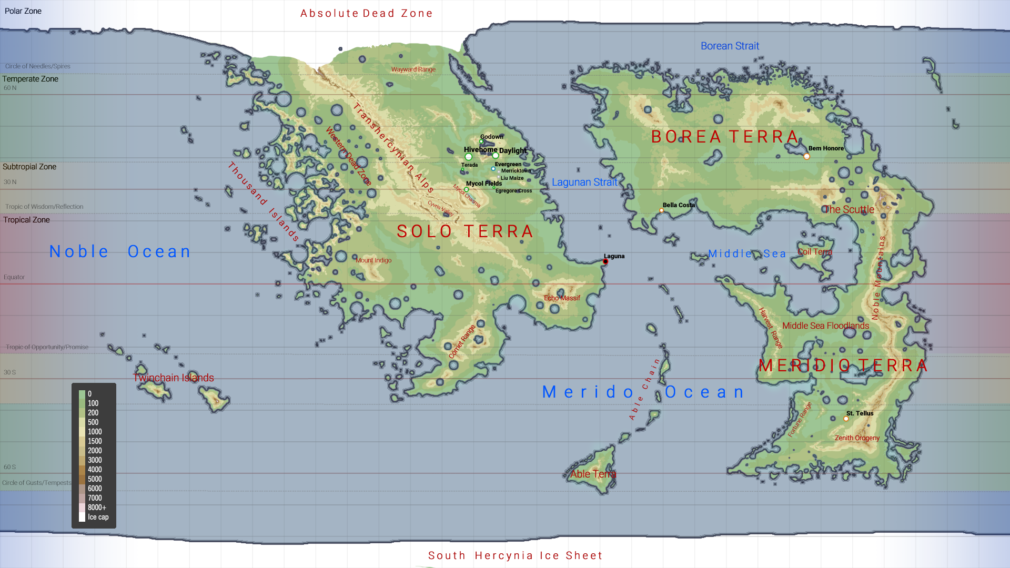++++
Polar Zone
Absolute Dead Zone
Borean Strait
Wayward Range
Circle of Needles/Spires Temperate Zone 60 N
BOREA TERRA
Bem Honore
Subtropial Zone
WestermDead Zone
Godown Hivehome Daylight
OS Terada Evergreen
O Merricktown
Liu Maize Mycol Fields
Lagunan Strait Egregore Cross
Transhercynian Alps
30 N
Mycol Chasma
Cypris Valley
Tropic of Wisdom/Reflection
Bella Costa
Ohe Scuttle
Thousand Islands
Tropical Zone
TERRA
SOLO TERRA
og se
Noble Ocean
Laguna
M
ddle Sea Coil Terra
Mount Indigo
Equator
Noble Mountains
Echo Massif
Middle Sea Floodlands
Comet Range
Harvest Range
Middle Sea Footing
MERDDI O SERRA ooogo cean
Tropic of Opportunity/Promise
• DOO
305
Twiachain Islands
Mer
Able Chain
100
St. Tellus
200 500 1000
Fortune Range
1500
Zenith Orogeny
60 S
SOOS
Able Tena
Circle of Gusts/Tempests
2000 3000 4000 5000 6000 7000 8000+ Ice cap
South Hercynia Ice Sheet

N1 = N2+N3/2
N3 = N1+N2/2
N2 = N3+N1/2

