You can message me on Discord if you have questions, comments, or feedback!
@DirkMcThermot#4873

This doc covers some things you should know about all of my maps. To see more info about each map, please check them out in the “Maps by Author” section. Thanks!

Q: What VTT are these meant to be used for?
A: Foundry. You might be able to make them work in other VTTs, but I can’t guarantee that they’ll work nicely without a decent amount of extra effort.

Q: What are the grid settings I should use?
A: These are the settings for most of my maps. For those that have different settings, I will note them in the respective writeup for those. You may need to use a simple image editing program (such as MS Paint, or Paint.net, Photoshop, etc.) to resize the image file itself.
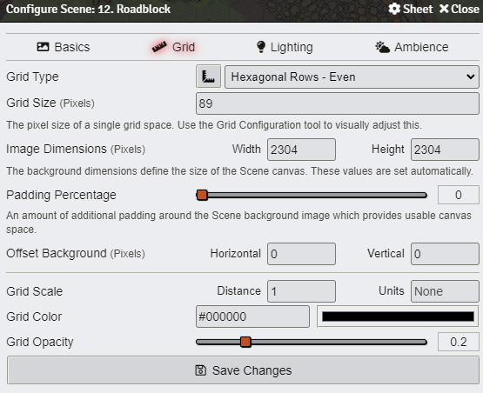

Q: How can I tell what’s meant to be used as cover, deployment zones, etc?
A: I have gone through the additional effort of drawing lines, templates, etc. on the maps in my Foundry world to demonstrate my setup for each combat. A screenshot will be included for each map titled “<CombatName>-FoundryAppearance.PNG” or something similar. Obviously you are free to do whatever you like with them, but I’m including them just in case they help.
Below is my key on how I color code various features of the maps.

Q: What map-making program did you use?
A: DungeonDraft. That’s why I provide the .dungeondraft_map files for all of them. If you have the program, you can download the map files and make any changes you like! Feel free to upload your versions and give me credit in some way, even if it’s just a brief note in the file name. I’m not a huge stickler about this but the credit would be greatly appreciated!

Q: What DungeonDraft asset packs did you use?
A: These are all the asset packs I have installed and may have used in each map. They’re all free and easily found by Googling.
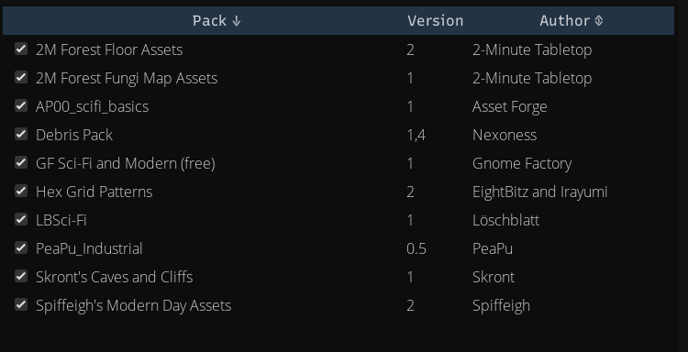

Q: How did you get things on the maps to align with a hex grid?
A: The “Hex Grid Patterns” asset pack. This adds two additional patterns in DungeonDraft that you can overlay onto the canvas. Here’s how to use it:
- In a DungeonDraft map, make sure you have the grid + snap enabled at the bottom.
- In the Design tab on the left sidebar, select the Pattern Shape Tool.
- Scroll down a bit and you’ll see patterns represented by hexes. Select the one named “Hex Grid Horizontal.” (I used “Hex Grid Vertical” only for the final combat encounter.)
- Place your cursor at the very top left corner of the map. Click and drag so that it covers the entire map. Now you have the hex overlay.
- Disable the grid + snap options at the bottom. Now you can place objects and mess around with stuff without having to worry about them snapping to a square grid.
- Once you’re done editing the map, switch to the “Select” tool on the left sidebar. Select the pattern overlay and delete it. Now you can export the map as an image file, put it into the VTT, and not worry about the original grid interfering with further setup.

Disclaimers
1. I am a fairly new and inexperienced Lancer GM. I have only been part of this game’s community for a few months now, and have only run a couple sessions in this system, so there may be shortcomings or flaws in my maps from a tactical gameplay design perspective that I simply don’t have the experience to identify on my own. I always welcome constructive feedback and criticism for anything I release.
2. Many of these maps were made by taking various degrees of inspiration from existing ones that other community members have created and shared. I will certainly do my best to give credit where credit is due in the respective writeups!
3. In terms of the visual aesthetic of the maps, they’re indeed very…DungeonDraft-y. This is because I only work with the program’s base assets and free asset packs available online. (I’ve already spent tons of money on this hobby so I’m trying to be more financially responsible.) This is another reason why I included the map files for people to mess around with if they’re not satisfied with the current look. On a related note - I am definitely not a particularly gifted digital artist, so the maps are FAR from the most visually appealing ones out there.
4. You’ll notice that I don’t have maps for a few combat encounters. That’s simply because I was satisfied with others that members of the community have already made. My primary goal with making these maps was to guarantee that I’d be able to import them into Foundry without having to do an ungodly amount of work to make everything align just right to the hex grid. If an existing map allowed me to do that, I didn’t bother making a new one.

