- Yi ARE SAFE
UNION IS HERE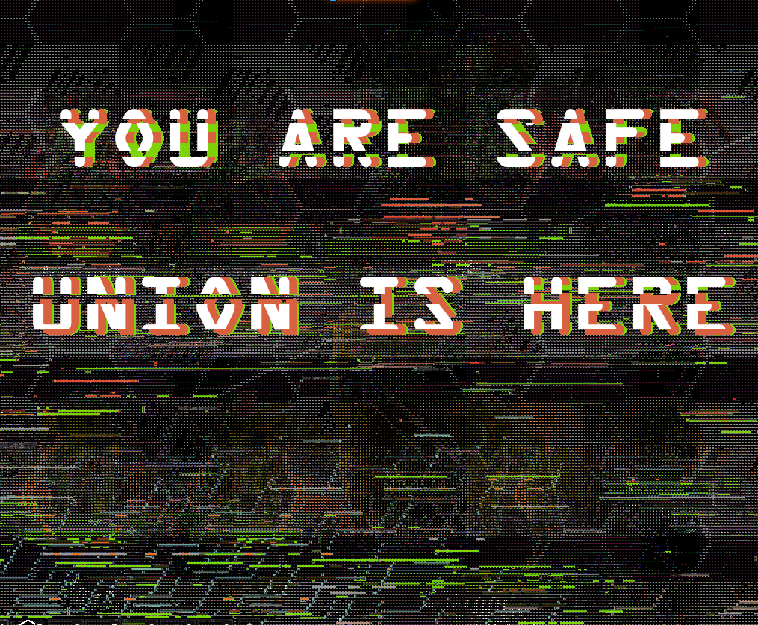
AR

