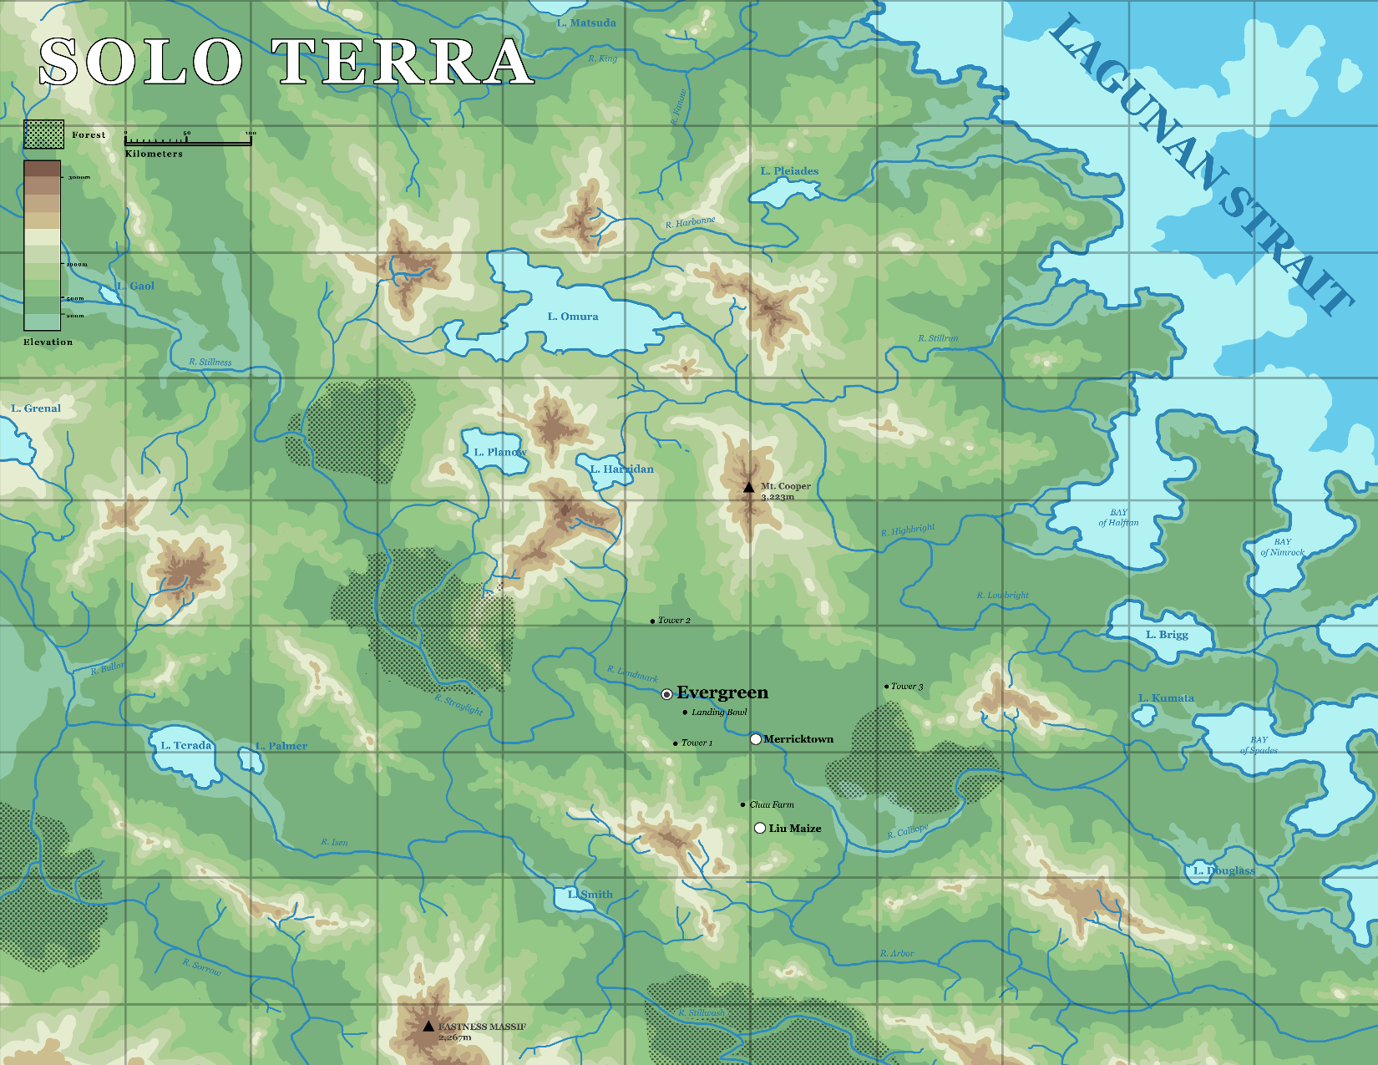
L. Matsuda
SOLO TERRA
LAGUNAN STRAIT
R. King
Forest
Kilometers
L. Pleiades
R Harbonne
L. Omura
Elevation
R. Stillun
R. Stillness
L. Grenal
L. Planov
L. Harridan
Mt. Cooper 3.223m
BAY of Halfrian
R.Highbright
BAY of Nimrock
R. Lou bright
Torcer 2
L. Brigg
R. Lndmark
.Tower 3
Straylight
o Evergreen
Landing Bowl
L. Kumata
L. Terada
Tower
Merricktown
JL. Palmer
RAY of Spades
• Cha Farm
Liu Maize
R. Calliope
R. Isen
1. Douglass
Ll Smith
R. Arbor
R. Sorrow
FASTNESS MASSIF 2,267m

