Hercynian Fauna
A field guide to the known fauna of Hercynia; while much of their history is shrouded in mystery, the modern day critters of Hercynia are a fascinating bunch. Dr. Eku’s field sketching period was cut short by the arrival of the mysterious raiders, so much of the artwork here is rudimentary, and she’s not been able to update her notes beyond simple bullet points.
[Translation: I hope to stick some proper art here for each critter, eventually, but don’t currently have the time to dedicate to it!]
WARNING — WALLFLOWER SPOILERS AHEAD! This document namedrops some important stuff from Lancer’s No Room for a Wallflower module, such as NPCs, locations, and the like. It also has some of my personal campaign notes, which will be marked in blue italics. [LINK] Here’s a spoiler-free version.

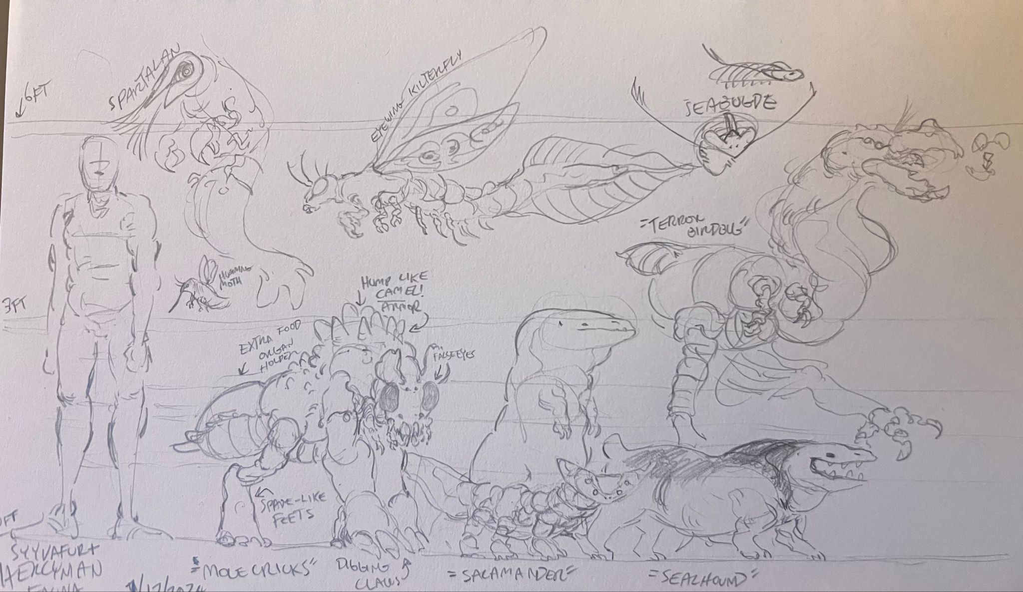
Page one; Humming Moths, Spartalans, Mole Cricks, Salamanders, Sealhounds, Terror Bird(bugs), Kilterflies, and Seabudges.

Naming Schemes: Common Name / Hercynian Native.
Humming Moth / Humilts.
- Small flying herbivores that look like Cradle’s moths. Solitary, feed on nectar from Hercynia’s larger flora species
- Can be kept as pets, and often are. Very common sight in Hivehome and Mycol Fields’ human population, alongside small gardens
- Tastes like quail – gamey, light, not very fatty.

Spartalans / Avshum.
- Heavily armored crustaceans capable of immense swim speed
- Pack animals, groups of 5-10
- Indigenous to oceanic and coastal waters, but moved inland after the TBK blew the ecosystem wide open
- Herbivorous, enjoys watergrasses & other plants
- Tastes like swordfish and lobster. Buttery, rich, delicious.
- Used to pull aquatic cargo and fishing boats in Hivehome. Some can be found giving small children and hatchlings rides through the bay, like a horseback ride.
  - Usage grew less common as the Machine started to advance out of the waterways; largely used for long-spanning travel routes

Mole Cricks / Mutzcal.
- Omnivorous arthropods that largely dwell in grasslands and mountainous regions
- Colonial, travel in packs of 3-5, hives are typically 20-25 strong including an egg-laying queen. Wild hives are smaller than domestic ones
  - Some hives are beginning to forgo a queen in favor of smaller, more nimble variants. Assumed to be because of Sealhound predation
- Used to be draft-horse sized or larger pre-TBK. Size now varies on the breed:
  - Smallest ones similar to golden retrievers in size.
  - Medium sized ones at about Mastiff sizes
  - Medium-largest Irish Wolfhound
  - Largest breeds top out at ~180cm at the shoulder. Only seen in Hivehome’s war-dog breeds, who are tough enough to go toe-to-toe with smaller mechs
- Mycol Fields breeds special thinner variants, like the greyhound to the wild var.’s mastiff
  - Carry supplies to and from Hivehome/Mycol Field/Daylight
- Multitude of uses, domesticated by the HUC.
  - Used as cart animals, beasts of burden, or transport animals for those wounded in the war, the elderly, or otherwise needing of mobility aids
    - Winter often uses them, as do many other aging Egregorians. Winter’s is a large faun-colored Mutzcal named Henrich, who functions as both a service animal and fellow puller of the tea cart.
  - Pick up on emotions well, often used as service animals to those wounded in the war.
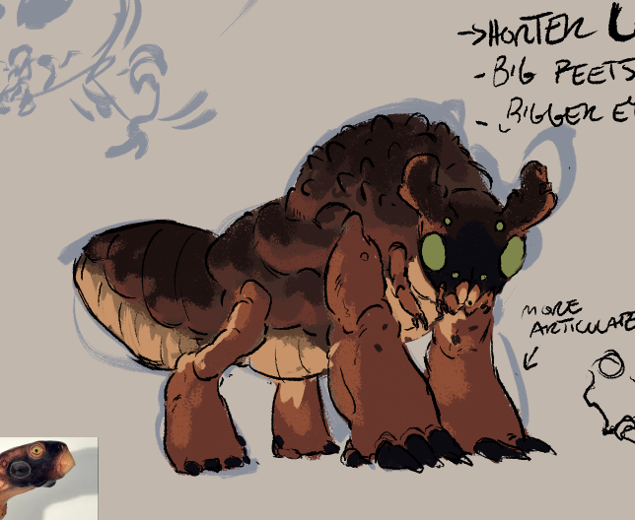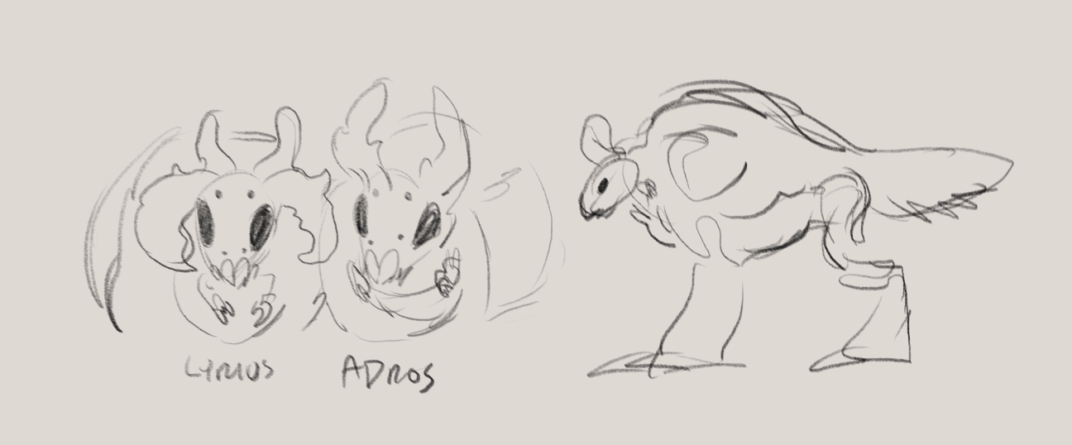
(Juvenile Mutzcal with common color scheme + Adult molecrick doodles)

Salamanders / Akitz.
- Small crustaceo-reptilians that dwell in forests, marshes, and rivers
- True omnivores, easily adapted to urban life and accustomed to humans. Racoons!
- Mildly toxic to the touch, very toxic to eat
  - Skin toxins induce a poison-ivy-like rash; meat toxins induce severe vomiting and inflammation. Native Hercynian animals, such as the Egregorians (and some humans), have adapted to this toxicity, and it simply tastes like Spicy to them
- Ancestors were much larger (dog-sized), but only the racoon-sized ones made it out of the Crisis; modern day ones are evolving to be larger in size once again
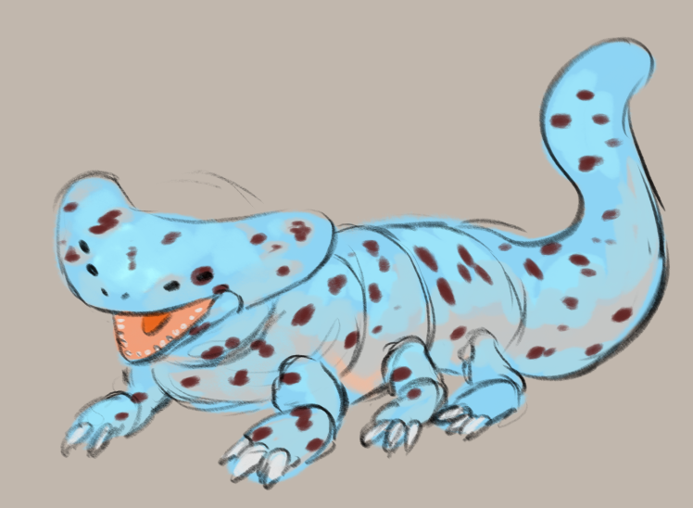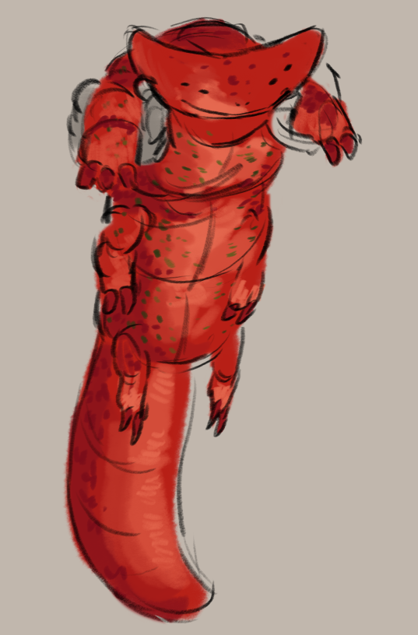

Sealhounds / Kraval.
- Invasive: originates from Argo Navis, used by SecCom to sniff out Egregorian hives via the eggs and young. Small populations survived the TBK and are carving out a niche in the rebounding ecosystem
- Semi-aquatic, akin to an otter. Ambush predators in water, chasers on land
  - Special taste for crustaceans, as the hunting genes bred into them all those centuries ago still thrives. Preys on Egregorian eggs when possible; killed on sight by Egregorians for obvious reasons
- Pack hunters, families are usually 3-10 individuals strong and never separate
- Can be easily trained to do scent work; very receptive to human reinforcement. Do not take to Egregorians very well for obvious reasons and are treated as kill-on-sight pests by Hivehome without exception

Terror Birds / Ovam.
- Large, ornery, omnivorous but largely piscivores. Usually found in the lowlands by rivers
- Usually solitary but tolerate others of its kind in groups of 2-3; more accepting (barely) of humans and egregorians
- Flightless animals used as beasts of burden when speed is of the essence; can’t carry as much as Avorns or Mutzcals, but can run much faster
  - Sometimes used by HUC rangers for this reason
- Hard to tame, even when raised from an egg. Donkey-like attitude
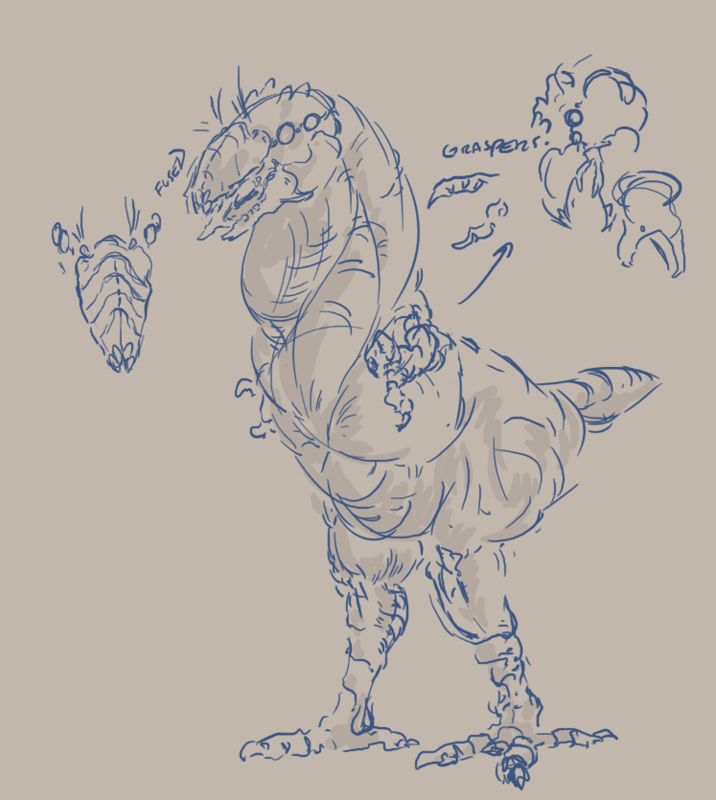
Kilterflies / Kilts.
- Dragonfly-like, similar hunting and living strategies (just big!)
- Solitary hunters, very territorial
- Sometimes used by the HUC to transport things by air, like tiny drones
- Favored prey is skipwhips

Seabudges / Avzcal / Bill.
- Trilobites :). Small, well armored, very delicious
- Water-dwelling, a multitude of species. Can be found in rivers, lakes, coasts, and beaches. Really took off after the TBK hit, wiping out many of its predators; new ones have begun to evolve, but it is still numerous
- Not intentionally herd animals, but are usually seen in groups eating from the same bed of plantlife

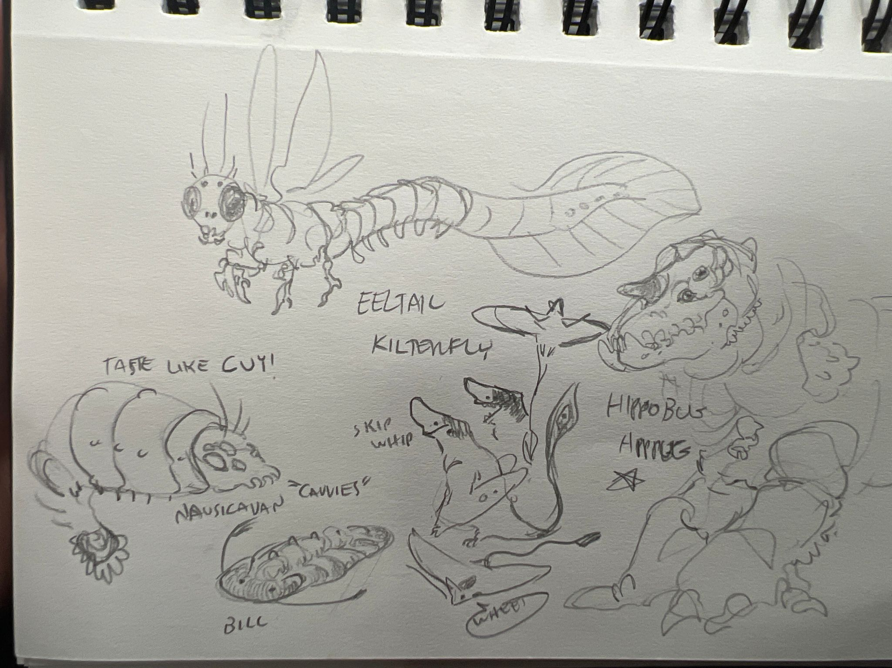
Page Two; Nausicavan/Cavvies, Bill (seabudge), Skipwhips, Hippobugs, Eeltail Kilterflies.

Armored Bugges / Cavvies.
- Semiaquatic relatives of the seabudge that dwell in forests, marshes, and rivers
- Herd animals, groups of 20+
- Raised by the HUC for food; tastes like cuy

Skipwhips / Skilts.
- Alien seagull, genuinely
- Travels in huge flocks, ranging from 4 to 50+
- Grown accustomed to humans from years of SecCom / HUC / Evergreen. Bold enough to take the food out of settlers hands
- Population viciously controlled in Evergreen, Grey Towns, Mycol Fields, and other above-ground towns. Not present in underground colonies
- Live entirely by the water, only going inland if major storms or flooding

Hippobugs / Avorn.
- Hippo-sized bugs; one of Hercynia’s largest species
- Semi-aquatic herbivores with an attitude like their namesake
- Often used as heavy burden pack animals by the HUC, but only those raised from birth

