Skill Trigger Combat Uses
Harrison Armory Dossier

I decided to make pilot combat more deep. Both to let players have more fun and strategize, and also so I could include more interesting enemies and missions. These rules are for this combat specifically. I hope you like them though.

Aside from the full action pilots normally get on their turn, Pilots now get a special Pilot Action. You can gain a second Pilot Action by expending 2 quick actions. So, on your turn, you could make an attack with a Medium A/C melee weapon (Full Action), and then attempt assault. To use the benefits of one of the skill triggers, you must make a dc 10 check. You roll a d20, add a relevant trigger. Say your trigger bonus is plus two, you roll a 13, for a total of 15. You may then gain the benefits, and immediately take the Jockey or Fight quick action. Despite all of these extra effects, keep in mind: This is a rescue mission. You cannot win this fight.

Act unseen or unheard
You become hidden until the start of your next turn.

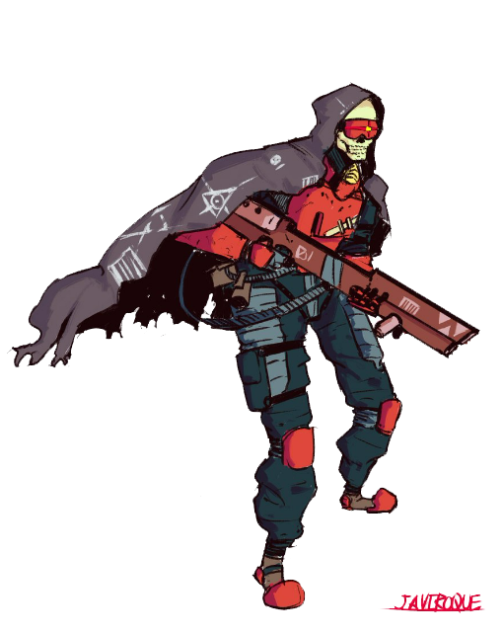
Apply fists to faces
The next time you hit with an attack, add your grit to the damage roll.

Assault
You may immediately make a Jockey or Fight attempt.

Blow something up
The next time you make an attack with a weapon that deals explosive damage, its blast increases by 1. You are ignored by the attack if you stand inside it.

Charm
All enemies in burst 2 gain +1 difficulty to hit you until the start of your next turn.

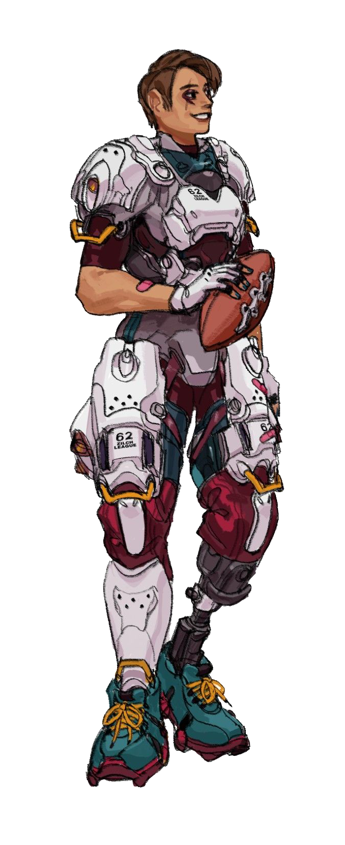
Get ahold of something
You may attempt this once per scene. You may choose one object on the pilot weapons or gear list, and instantly gain access to it.

Get somewhere quickly
Either your movement speed doubles or you ignore engagement until the start of your next turn.

Hack or fix
A target enemy of your choice gains lock on and gains either 1 heat or is moved 1.

Invent or create
You may attempt this once per scene. Choose a piece of pilot gear and substitute it for one of your own.

Investigate
You scan target enemy of your choice within range 8.

Lead or inspire
Choose an ally. They gain one accuracy on their next check, attack roll, or save.

Patch
Choose one pilot that is adjacent to you. They restore one hitpoint and clear the down and out condition. A pilot may only benefit from this once per scene.
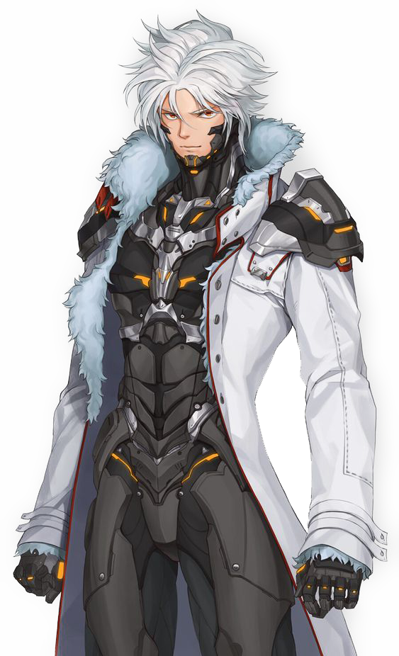

Pull Rank
All enemies in burst 2 gain +1 difficulty to hit anyone but you until the start of your next turn.

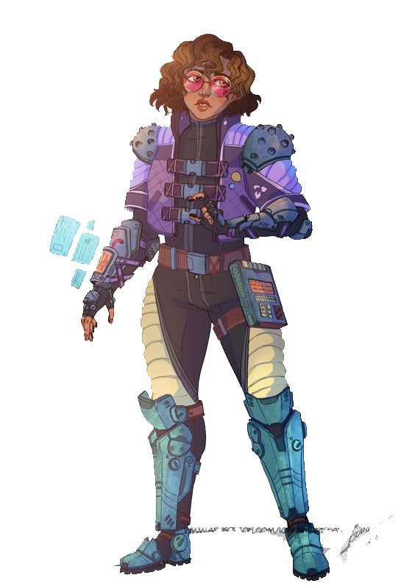
Show off
Make an attack with a pilot weapon at +1 difficulty. Choose an ally that can see you. they gain +(Your Grit) on their next attack roll, skill check, or saving throw.

Spot
An enemy within range 8 gains lock on until the start of your next turn.

Read a situation
Receive insider knowledge of the situation and advice for a successful course of action.

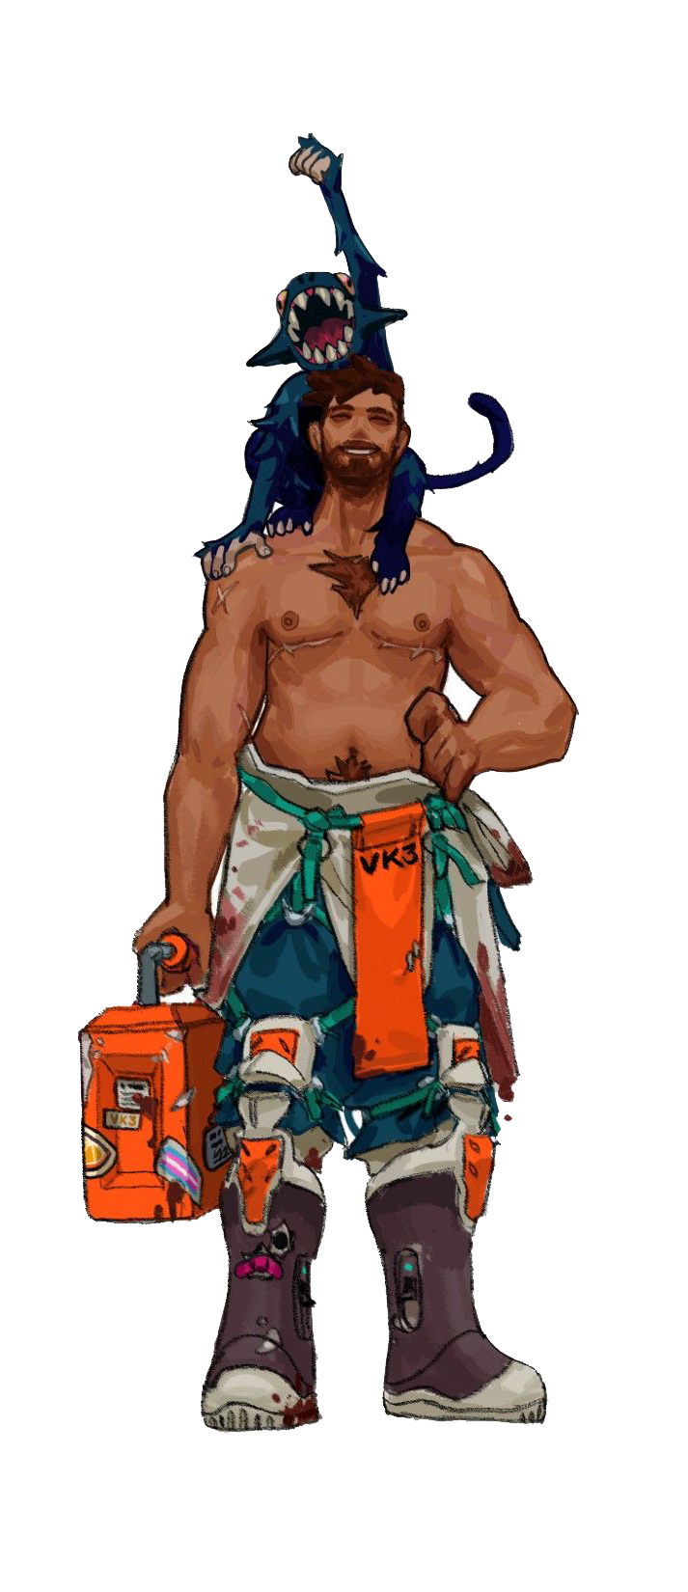
Survive
May be attempted once per scene. Until the start of your next turn, if you would be reduced to 0 hit points, you are instead reduced to 1.

Take control
Once per scene, you choose two allied characters within burst 4. With their consent, you may switch their position.

Take someone out
Choose an enemy within range 8. They take 1 point of unavoidable damage and you learn their current hp.

Threaten
An enemy within range 8 gains +1 difficulty on attack rolls on you until the start of your next turn.

Word on the street
Learn the armor, pilot gear, and weapons of one enemy of your choice.

Stay Cool
Clear all heat or one status condition afflicting your pilot. You add 1 accuracy to your next check or save

