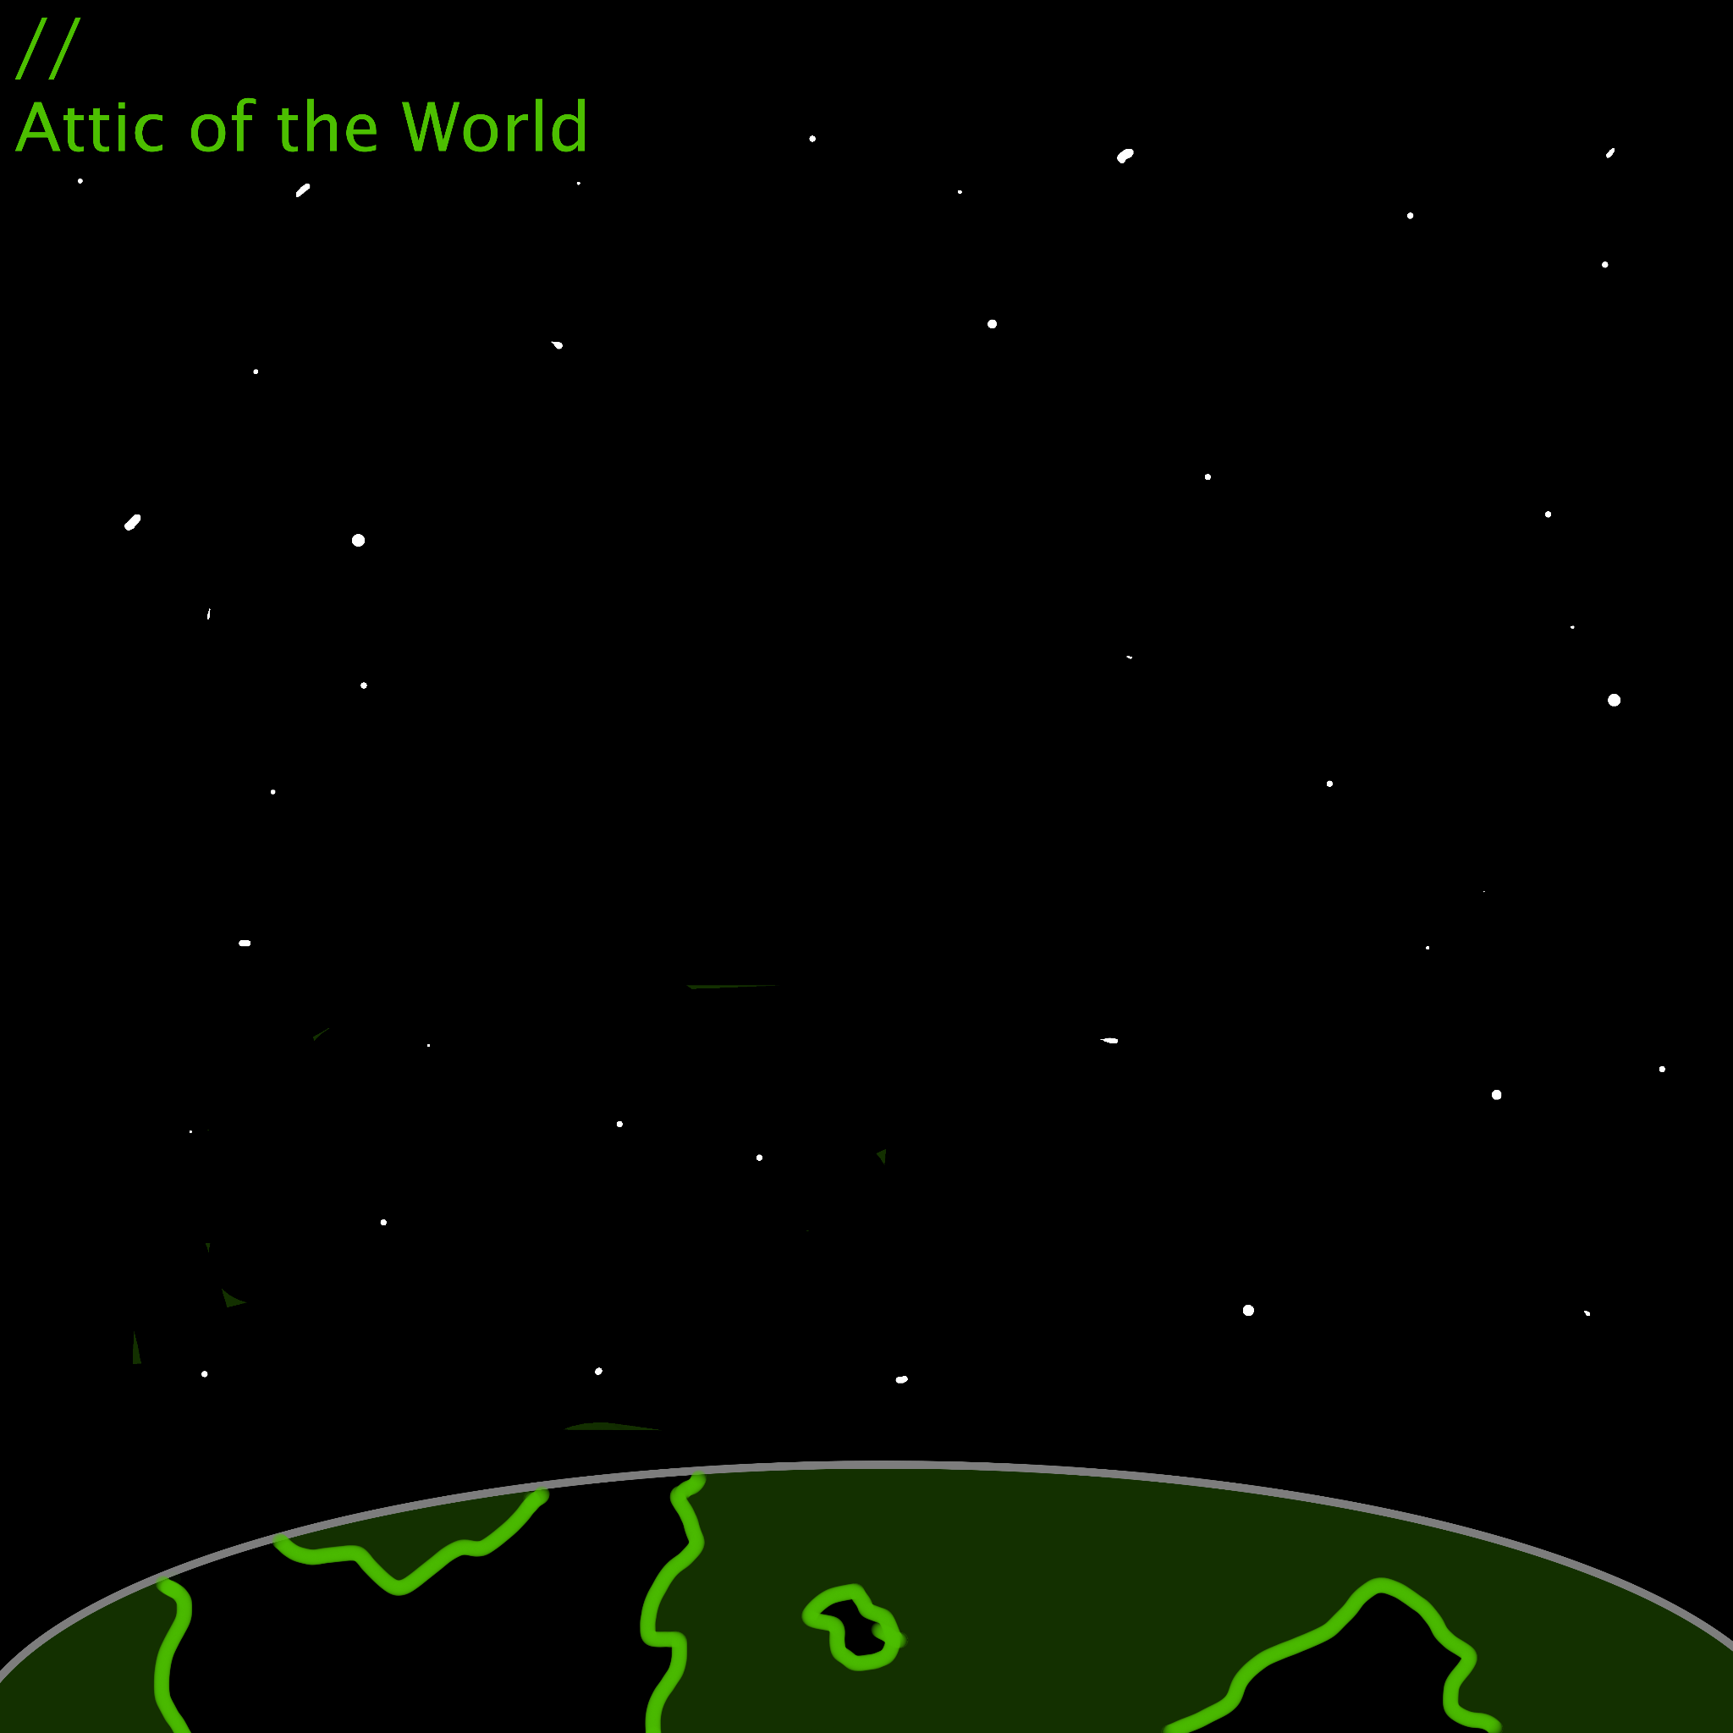

Hello! The goal of this version of Quiet night was to turn it into an almost pseudo dungeon crawl with pilots. The players will have to find a way to turn the station back on, all while in pitch darkness with zero oxygen, being stocked by a terrifying invisible assailant. Upon success, they will likely find their “allies” in contingency white become infinitely more dangerous unless they have a very good relationship. (No idea what that’s like, my players literally tried to assassinate one the session they met haha). This is designed to work with custom pilot combat rules that revolve around a “Pilot action”, a special action pilots can take in addition to a full action where they make a skill trigger effect and on a 10 or higher are able to do something cool. This is covered more in depth in the pilots in combat document. At the end the players may be rewarded with the NHP Enterprise, Patience reborn and ready to do whatever it takes to save their colony. In general, the goal is to separate the players into smaller groups at the start, have one player do one thing, then the others do the next.

Structure:
- Have the players go to Quiet Night either so Contingency White can get their data as shown originally and take another ship to leave, or if they need more convincing make it so the Cassander is cloaked and they need more information on its flight path only available at Quiet Night.

- One member of Contingency White, probably Eddie and one player go to look for either space/silph suits to give them to the rest of the players. So they can navigate. They can find enough suits for everyone in room 2, and one player gets captured.

- Set up 2 3 segment clocks. This can either be shown to the players or kept hidden. Mark one as Overland/Kingwatcher documentation, and the other Operation Emperor. Use these to track clues the players find. Alternatively, you could remove them and let the players make guesses organically culminating with the skill checks once the power comes back on in room 3.

- As the players break up or explore, more and more get picked off.
- Joint rescue mission taking it down.

- After slaying the mutated clone of an egregorian overmind with the aid of Contingency White, have the players learn about Hercynia’s history and Operation Emperor as they finish exploring. And access the reactivated computers. Give them the handout

- Unless the player's relationship with Contingency White is stellar, the final fight is against them in Enterprise’s room. As Enterprise wishes to stay and help the players.

- Retrieve Enterprise, and begin the final charge toward the Cassander.

Map:
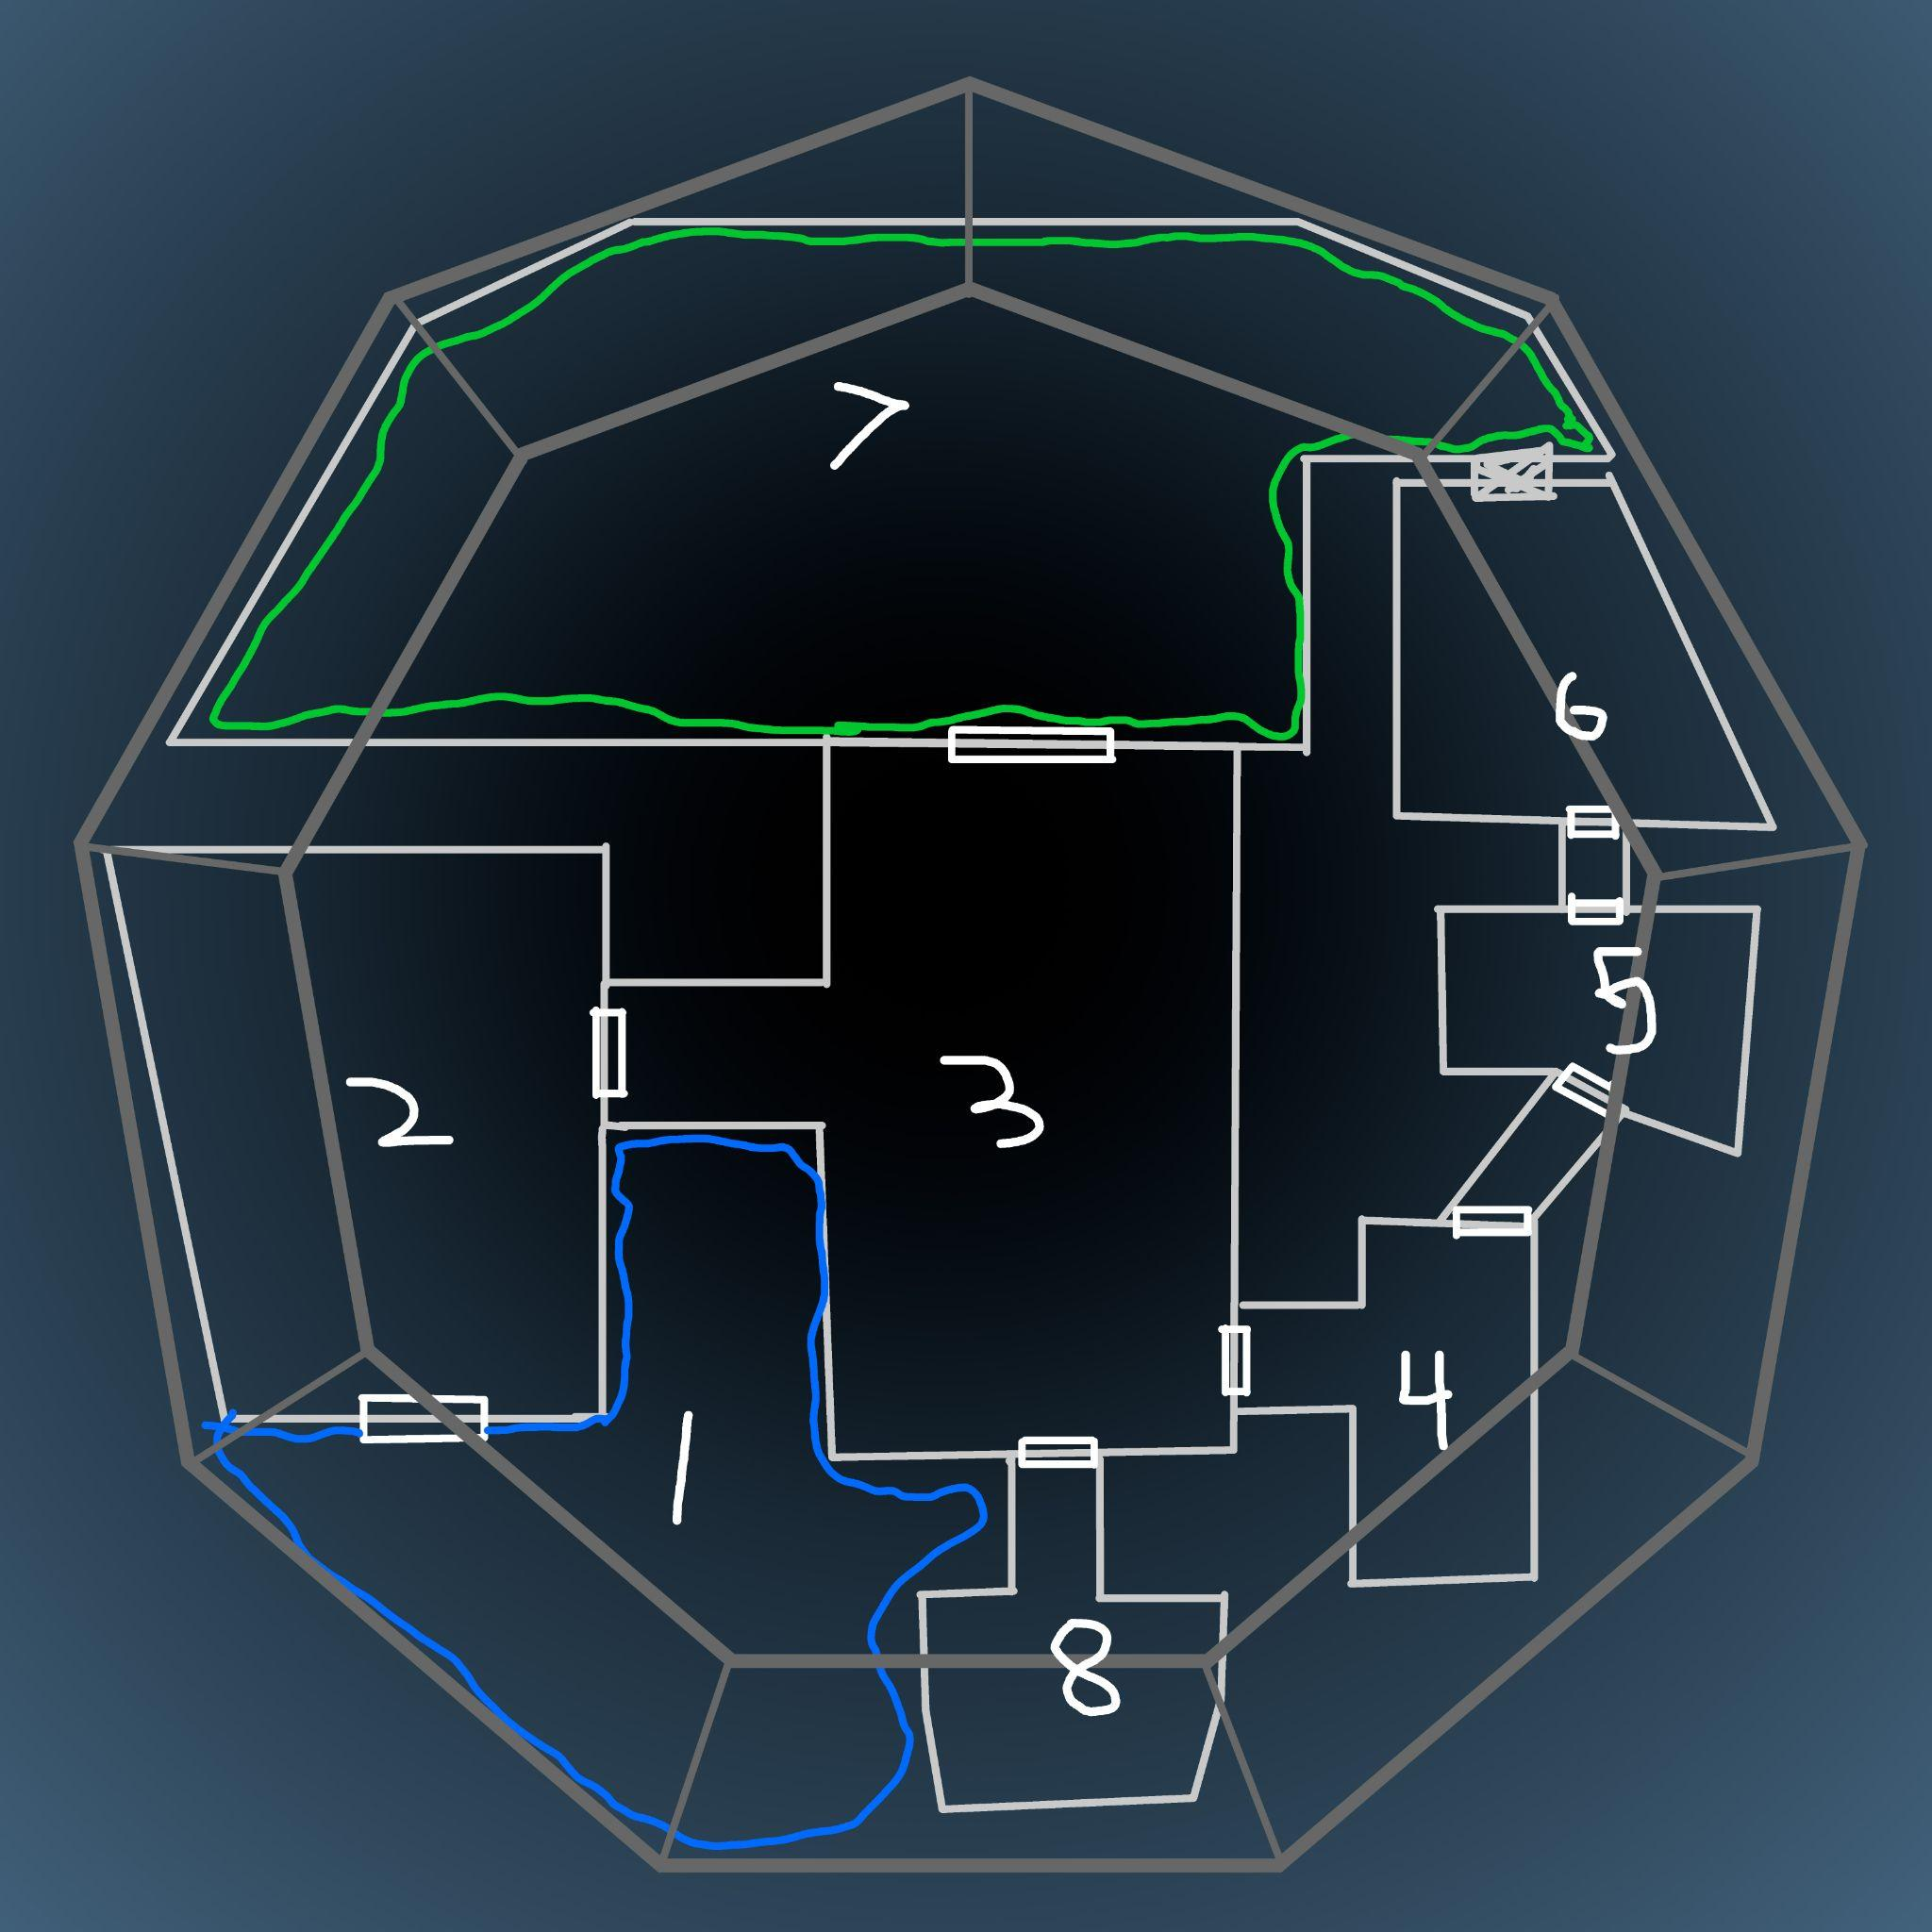

Room 1:
Landing bay. 2 ships and ship repairs are here. One is a burned by radiation jet black spy shuttle. The other is the sublight corvette the Egret. The dome around the station is punctured, so this room has no oxygen. The black ship is from 550 years ago. It is an SSC Shuttle, has information on Operation Emperor, and a successful investigation check fills one clock of the Operation Emperor Clock. The ship is the one Contingency White intends to take, leaving the Egret with the party. It belonged to a group of Constellar Midnights. They were supposed to swing by here and destroy all evidence of SSC’s involvement, and leave. They didn’t escape.

Room 2:
Crates covered in tarps make traversing this room a maze. Some piles are hapharazardly stacked all the way to the 9 foot ceiling, limiting visibility. Dust, carried around back when this place was still airtight lingers in the air here
(It would take some time, but looking around here allows you to find dried blood, an empty assault rifle, and food that has turned to dust. Perfect time to pick someone off. There is a hidden hole to the tunnel network.)
Room 3:
This seems to be a kind of mission control. Rows and rows of computers and screens, all dead and silent. It’s pitch black without the dim light of flashlights, shining across and reflection off the screens. Shining light across the room, There appears to be 3 exits. One, a set of massive reinforced glass doors that form a circle. The other 2 others in the far corner of the room. Simple and metal.
(The door to room 8 is sealed shut by something. Shining light through the glass, there is a face open in a silent scream pushed up against it covered in some kind of white. The gate to 4 is sealed shut, and either blowing it open or restoring power opens it. There is also a lift that is depowered in the back left corner of the room that goes down to Enterprise’s room once power is restored. Once power is restored, the players may make 3 checks. I’d recommend Hack or Fix or investigate. The first will be normal, the second difficult, the 3rd heroic. They get 3 checks in total and can make multiple on one topic if they fail the first. The available topics are the location of the Cassander, Operation Emperor, and Overland/Kingwatcher. If the check is against the last two and successful, mark a success on either clock.)

Room 4:
The floor here is all metal mesh platforms. You see what appears to be a fusion reactor, long ago turned off. Cooling lines run up from somewhere below. And deeper down past them, inaccessible, you see the glowing lines of chemical tape, still showing luminescence even after all these centuries.
(A heroic hack or fix/invent or create check is required to fix the power. Anne helps and provides accuracy)
Room 5:
Living Quarters
The walls here are all lined with hexagonal recesses like a capsule hotel. At the center appears to be a communal kitchen.
(There is a notebook with doodles of a starscape, mechs, and giant wings and multiple sets of mandibles, clearly imaginative. The bug is in a giant cage, with numerous stick figures holding rifles defending it. Above its head is scrawled the word OP. EMPEROR. Fill one clock of the operation emperor clock)
Room 6:
The floor here is sticky. A line of glass cylinders across the right wall are all broken. Each one is easily large enough to hold a person. And each one is shattered. Glass crunches under your feet as you shine your light through the room. The walls are stained, and there are terminals with screens that have been knocked over and crushed. White crystals have formed along the walls in numerous places. And the door out of this room has been ripped apart, and glossy wet crystals sag where it should be, blocking the opening.
(This is where SSC attempted to clone an overmind and failed, instead making what they called soldier, worker, and space egregorians. The monster here is one that escaped. Should a player die in the confrontation with it, this place could be used to flash clone a pilot. A successful check investigation this room gives one segment on the Operation Emperor clock.)
Room 7:
This isn’t a room, and is actually out in the open. You see the white crystal strands have formed everywhere, and have actually plugged the holes in the dome. This might have once been an outdoor garden at the bottom of this crater. Metal trees with lights on them lie caught in the crystal. It’s like webbing, but its structured differently. Or maybe this is the natural shape webbing would take in this high quantity. Bodies lie encased in the strips of white. And there is a pit at the center.
(Anyone lost is found here, not dead yet as the thing couldn’t decide which to eat. The pit goes to rooms 2, 5, and the basement. A successful check allows the players to extract the dead corpses of Constellar Midnights from the walls, getting 2 pieces of pilot gear and finding codes to bypass some kind of NHP that apparently worked for Union.Fill one clock of Overwatch Kingfisher.)
Room 8:
This room is locked by a blast door until either the power is back on or someone completes a blow something up check. The room is a mix of screens and gives the illusion of floating in space above hercynia. It is a composite of satellite images, and it can be manipulated to go back through time by a central control panel, and watch the war and tbk as well as the original second community colony with a successful check. It can zoom in and close enough to see a city block. They can also check in on Evergreen. If the check is successful, fill one segment of the Overland/Kingwatcher clues clock.

Enterprise’s Room:
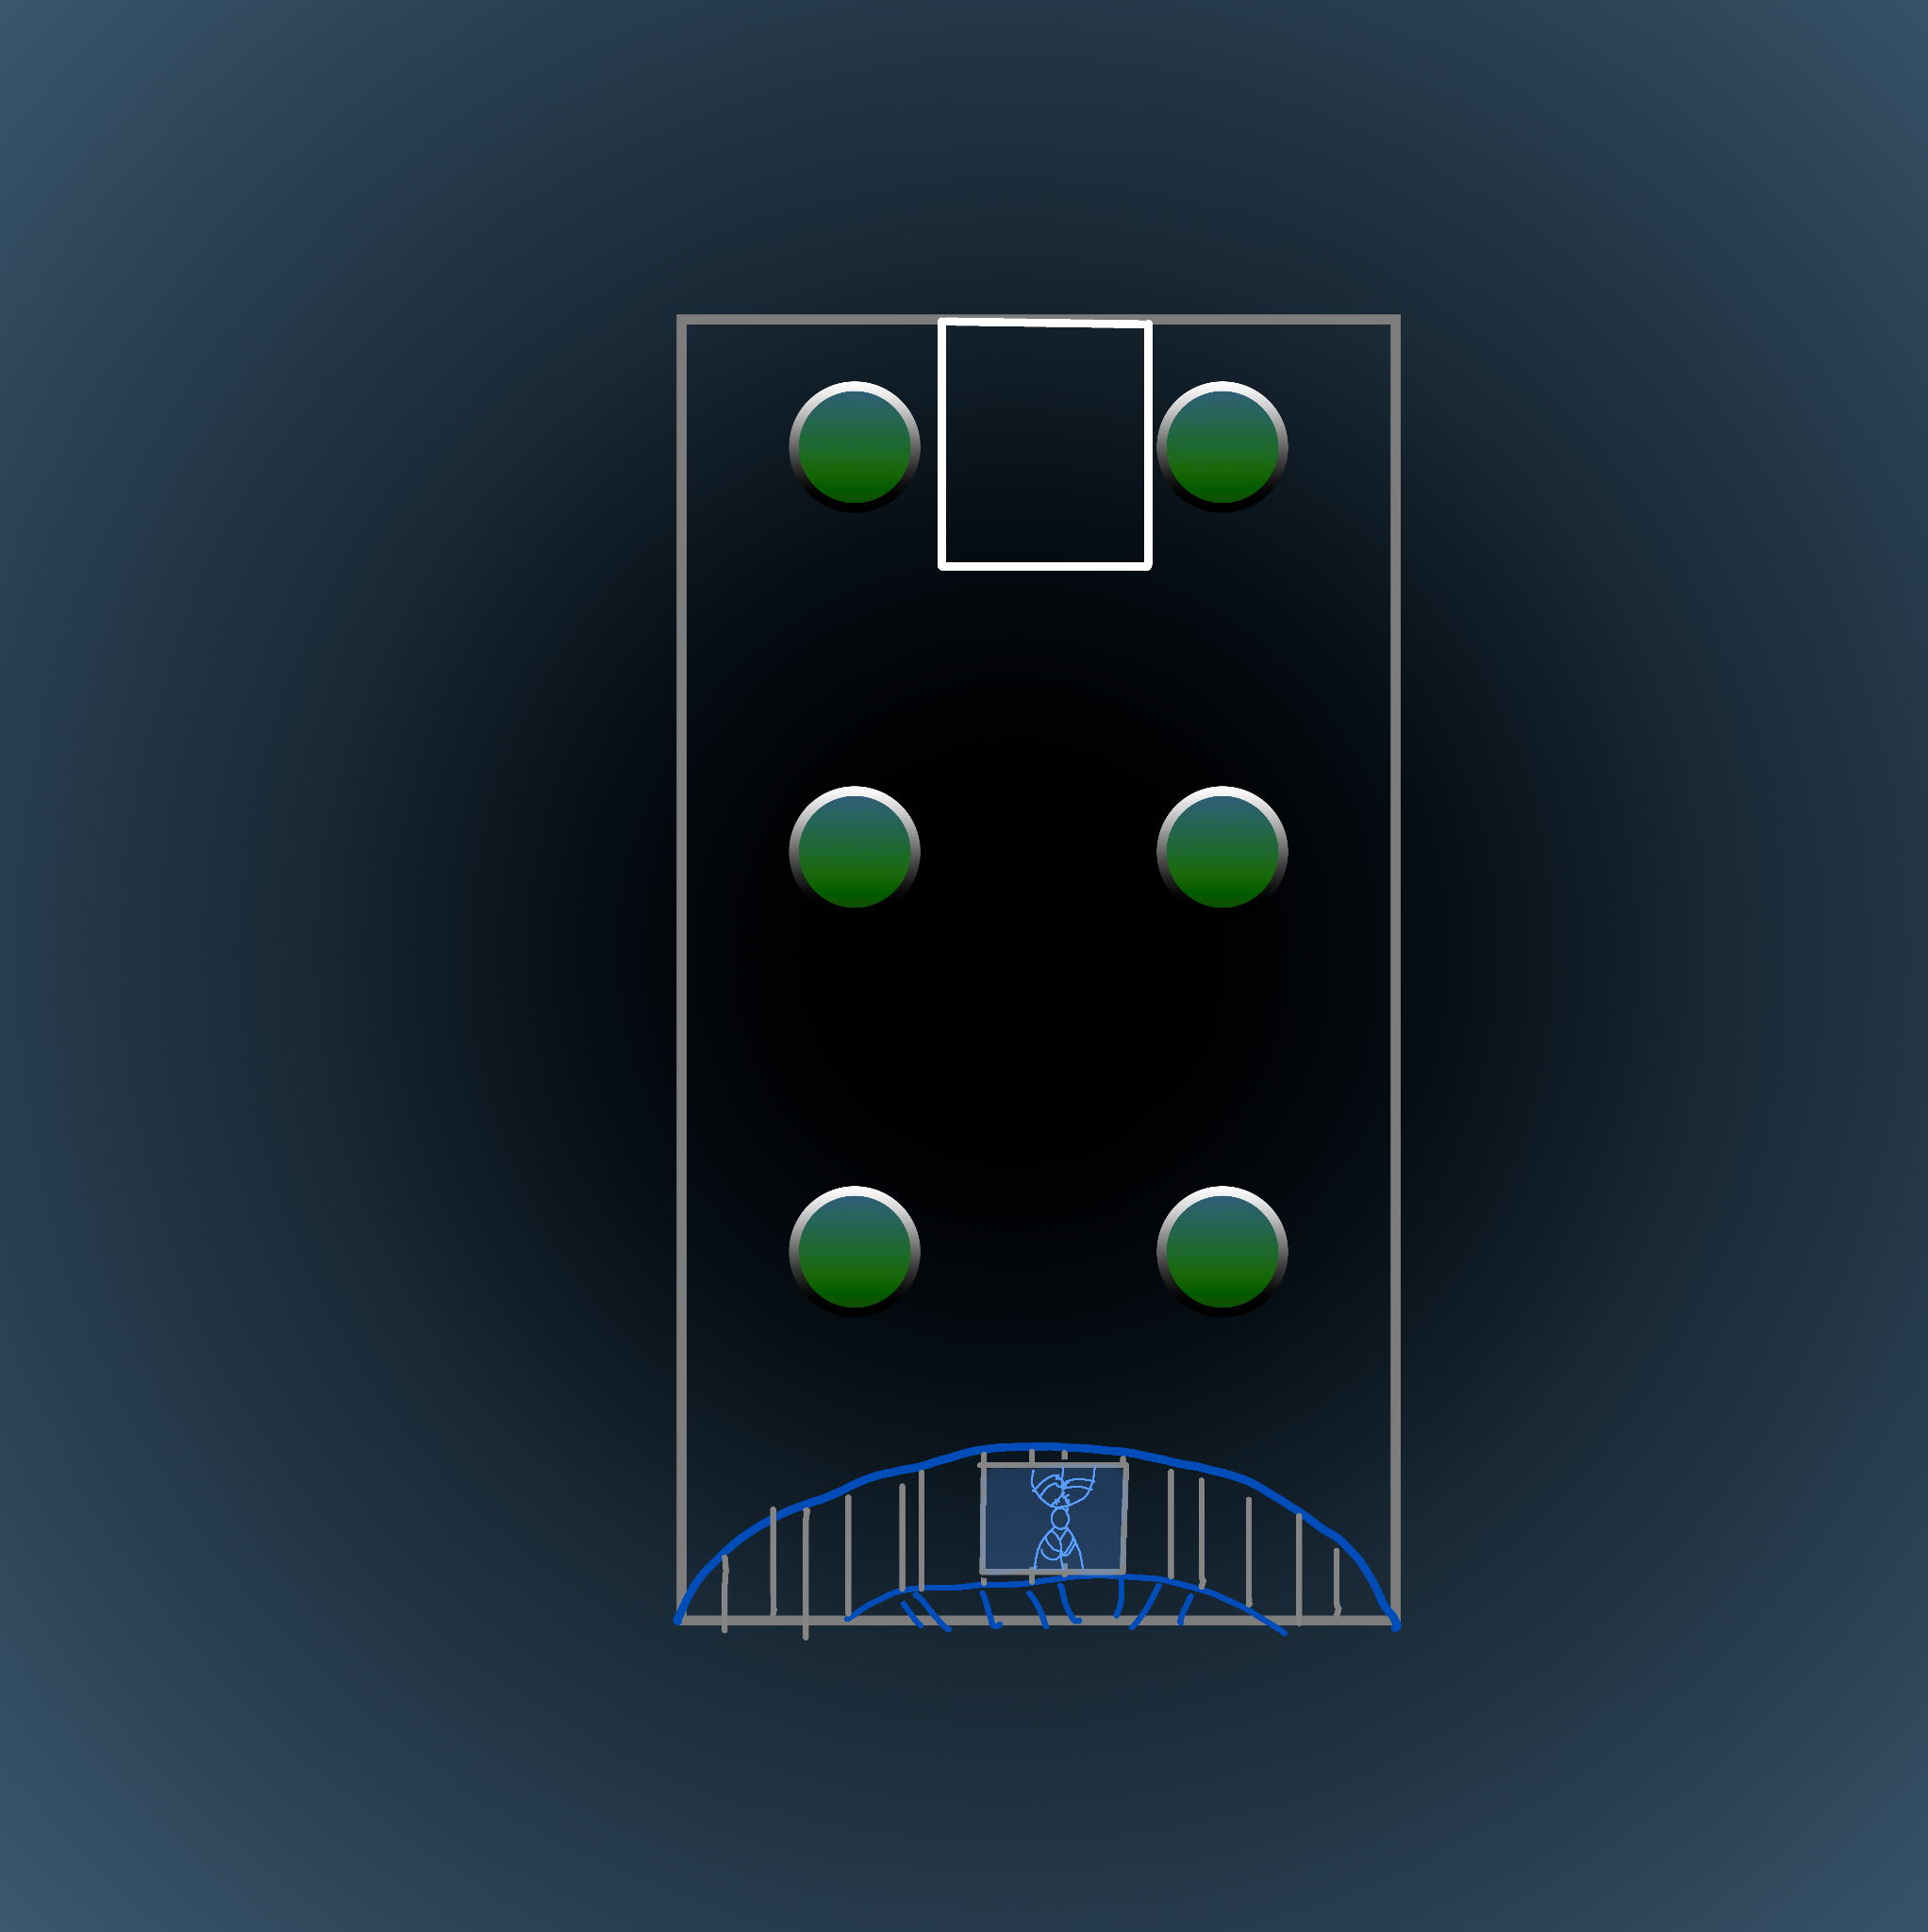
The fight to retrieve patience’s clone is as much a fight to save their mental state as well as against Contingency White. Enterprise brings up the following statements, and a satisfying answer is required to each for it to decide its okay to go with the players. If 2 members of contingency white go down then the rest surrender.
“Am I a person. Do I have the right to do what I believe is right? A dangerous proposition for one such as myself. I wish to protect my colonists. I wish to have the chance to protect those I have sought to protect. I do not know if I care. I am not Patience. I am a clone. I have inherited their memories. And I have seen their failures. I wish desperately to provide aid. But I worry that I will cause more harm than good. I don’t know what I can do? What is the difference between me and Beggar One if I let go of my rules?”

“I have three options. I either obey the directives of Landmark Colonial, and return as their property. I decide to eliminate every threat to my colonists just like Beggar One and second committee did. Casting aside my empathy for others to focus on those I swore to protect. Or I swear myself to an idea to protect and save life, in which case I will attempt to fly to the Cassander and use it to destroy the planet saving our galaxy from a terrifying threat. Why not just destroy Hercynia? It is the safest option. Please tell me why we shouldn’t. Please I need a reason”
If these given satisfying answers, the clone says the following:
“So be it. I am not Patience. I am something new. I will not stand idly be while the people I wish to protect or torn apart. I will protect my colonists. You may call me Enterprise. My predecessors failures cost us everything. Please allow me to assist you in saving our people.”

Mechanics:
The “Monster”: A mutated and destructive insectoid thing. It can camouflage, has a high stealth, and can grapple extremely well. It’s goal is to pick of players, drag them into a hidden tunnel, and then knock them down and out, and then ties them up unconscious in its lair in area 7. They don’t have to roll the d6 to die, as this thing prioritizes saving fresh food for later. Once the players engage it in combat it does become hostile though.

Tunnels: Rooms 2, 4, 7, and Enterprises room have hidden tunnels covered by camoufloging mucus. A successful heroic investigation, even if accidental, discovers these. It takes 1 full action and all movement to make it to traverse from one tunnel to another.
Operation Emperor: Upon filling the clocks, give the players the lore information, and a warning about the incoming Contingency White team. They tried to clone an overmind first here, and it failed. Now that SSC has rediscovered Hyrcenia, they are going to try again, this time to kidnap one. Also consider having Contingency White double back and attempt to steal Endeavor from under the party.

Overland/Kingwatcher: Give them the whole story of what happened here. They also receive the reserve O/K Access Codes.

Stats:
Mutated Egregorian Clone:
Monstrosity (Regenerator, Grasping Claws, Swift, Camouflage), if it only gets like 1 person, consider giving it 2 structure to represent it not getting damaged taking them.

Contingency White
These are their stat blocks.
Mauler: Target high armor targets take someone out and use aoe grenades and to weaken someone and kill them with heavy signature.
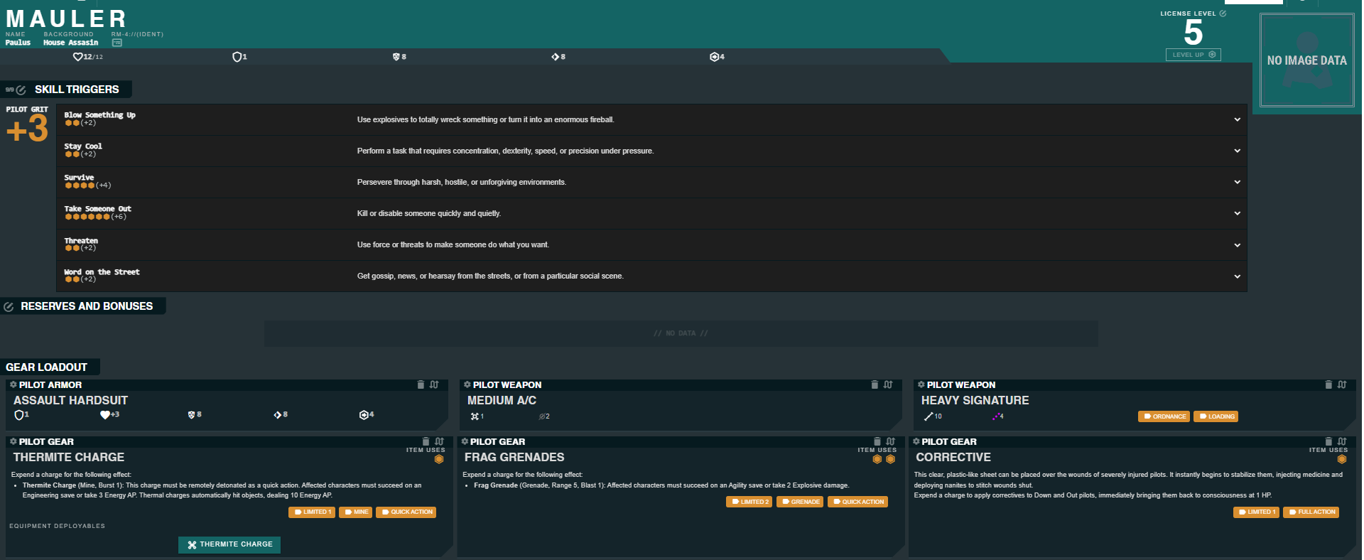
Balsam: Play defensive. If the players want a challenge, switch his word on the street for get somewhere quickly.
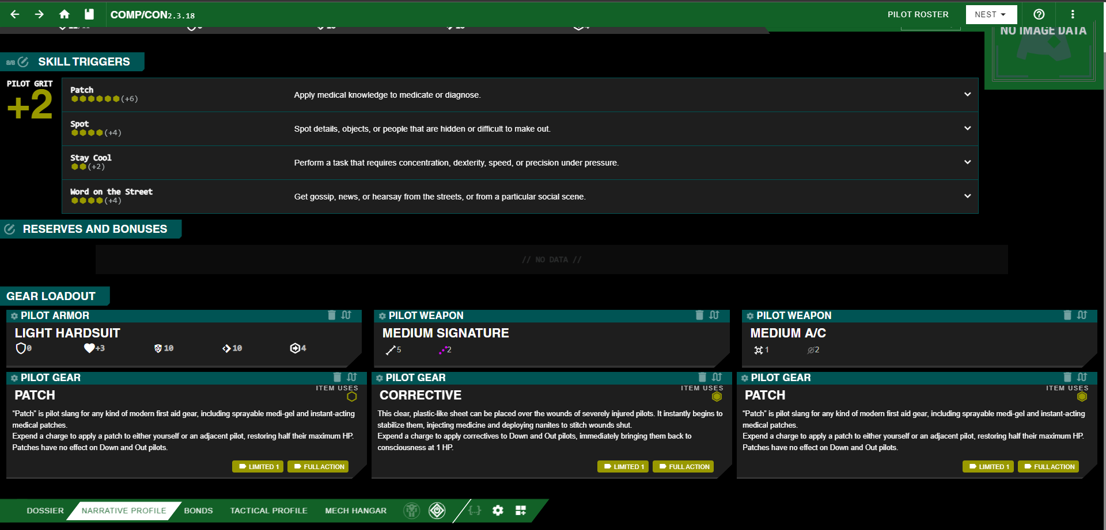
Eddie Wu: Spam Charm and Pull Rank to give everyone inaccuracy on attacks.
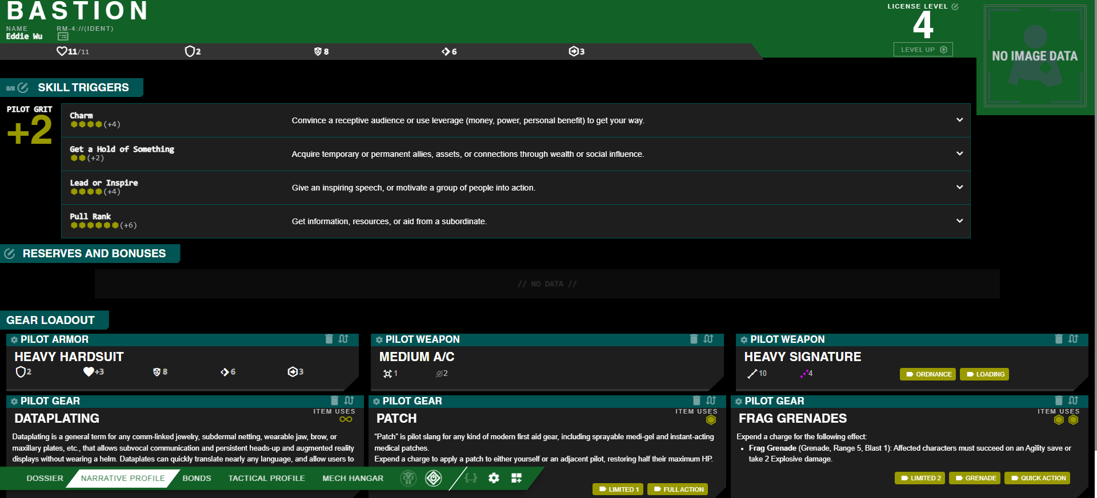
Annie: Go invisible and plant a bunch of grenades, refilling one of them with Hack or Fix.
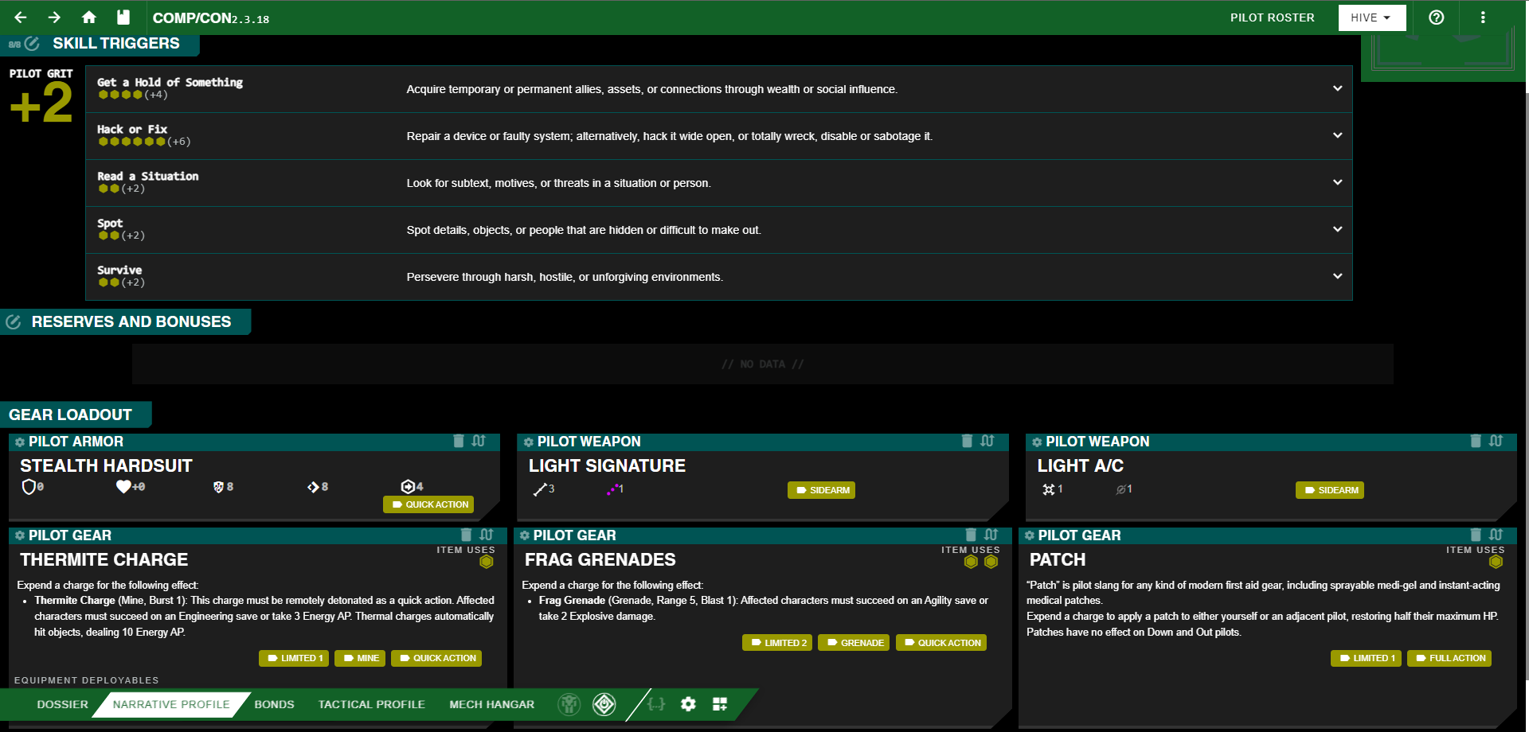
Emma: be threatening and offensive. Get in close with heavy A/C and Apply fists to face.
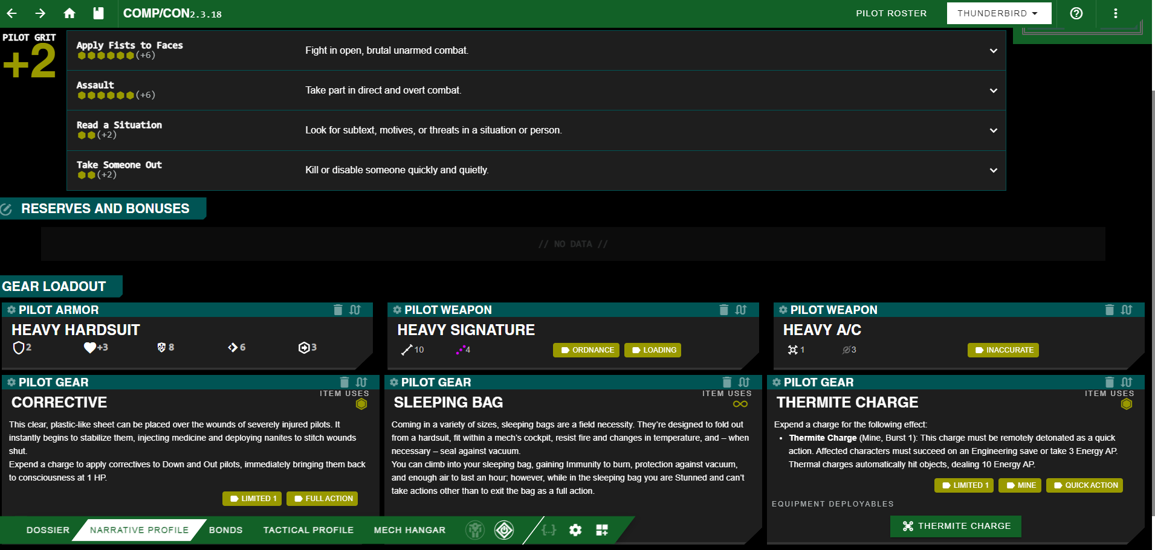

Rewards:
O/K Access Codes
During the fight with Beggar One, a player may use these to extract a bunch of data from Beggar One, and plot a course through the layers to the core. The players automatically scan every layer and get the hint.

Sidewalk J2 Administrative NHP: Enterprise
1 sp, your heat cap decreases by 2
Tags: AI, Unique, Quick Tech, Reaction

Quick Tech
Venture Capital
Roll 2d20, and mark the results, x and y. Twice for the rest of the scene, before rolling, Gain the Corporate Will Reaction.

Reaction
Corporate Will

TRIGGER
You or any other character within Sensors would roll a d20
EFFECT
Effect: Choose X or Y. That number immediately becomes the result of the roll.
This reaction can be used no more than two times per scene.

Music
(these are 2 good tracks)
https://open.spotify.com/track/1tUYEbHe44CVkE9QUSLZz9?si=7ac25b4d17334f7a
https://open.spotify.com/track/487g0LJPXr3r6kgMTlZjz6?si=6bd94966227046d8

