SALT’S SEAS

INTRODUCTION

The following is a narrative scene for the No Room For a Wallflower adventure module for Lancer and contains spoilers for the campaign.
It is intended to work with the Bonds Rules on Pg. 86 of Lancer Field Guide to the Karrakin Trade Baronies.
This narrative subquest is triggered by meeting Salt, the old Egregorian fisherperson. The first time the PCs board a gondola while exploring Hivehome they will run into Salt who will be using the vantage point offered by the Gondolas to scout out his traps, several clusters of Crust(acean) Pots, scattered about the subterranean sea. They will also mention that they have seen curious bubbling on the sea to the north and suspect an old cave may have opened up which may contain valuable salvage.
After meeting the PCs Salt will ask them to meet at a staircase leading to the mid-isle quays the next morning, whereupon they will lead the PCs to their small fishing trawler. An old propeller driven boat that glides silently out of the quays and out to sea.
The boat is well kept but showing obvious signs of age, the paint is scuffed from frequent scrubbings. resins, though polished flat, are obviously filling voids in the hull. A huge net is tightly coiled around the aft of the ship like a thick rope. In the center of the deck is a massive spool of durable looking well oiled inch thick cable.

OBJECTIVE
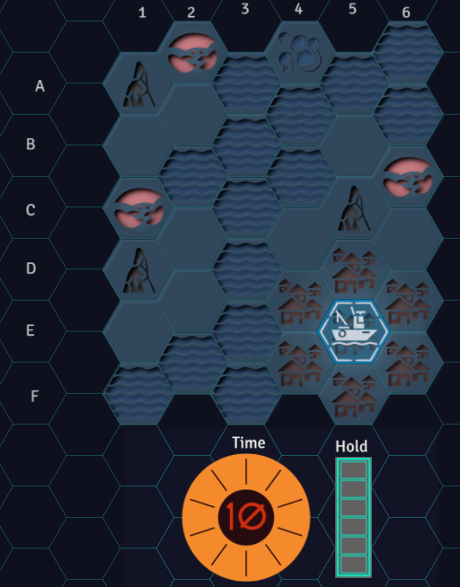
- Fill Salt's cargo hold with spoils, either salvage or sea life from their crust pots before the lights are shut off for the day.

THE MAP

THE TILES
https://drive.google.com/drive/folders/1og-3SgtP5fPGpo7HyoXRwQNLUoayVir7?usp=sharing
- HiveHome - A size three grouping of structures.
  - Movement to any tile within HiveHome does not cost Time.
- Shallows - Relatively calm and shallow water. Adjacent to Stalagmites, prime fishing areas.
- Deep Water - Underwater ocean currents have carved deep gorges beneath Hivehome, prone to strong ocean currents and rough water.
  - See SAIL THE SUBTERRANEAN SEA below.
- Stalagmites - impassible blockers, millennia old and sometimes sculpted and supplemented for structural strength. The water adjacent to them is usually more shallow and teeming with life.
- Bubbles - A sure sign or something buried, waiting to be unearthed. Durable Hard Suits will be necessary to combat the tremendous water pressure deep below the sea.
  - See SEARCH FOR SALVAGE below.
- Crust Pots - These shallow tiles are where Salt's traps are located.
  - See BRING IN THE CATCH below.

THE SETUP
On a 6x6 Hex map Place Hivehome, a size 3 area, in one corner of the map. place 3 stalagmites, you can do this randomly by rolling 2d6 to determine their location on the grid. Surround the stalagmites with shallows.
Place three crust pots in the shallows adjacent to the stalagmites but at least two spaces from each other.
Fill the rest of the open tiles with deep sea tiles. Place the Bubbles tile on the opposite end of the map as Hivehome. You can roll 1d6 to choose a tile if you’d like.
Move a few tiles around until you’re happy with your map.
Place Salt’s Trawler in the center of Hivehome.

NOTE: Do not reveal the map to the players.

MECHANICS
Set out a filled ten segment Time Clock. This represents movement points. When time runs out, Salt will declare that they must return to Hivehome before the lamps are cycled off.
Set out an empty six segment Hold Clock. This represents the room remaining in Salt's Cargo Hold. Fish and wildlife caught in Crust Pot tiles will fill the hold by the indicated value for the roll. Each item of Salvage adds +1 to the hold.
Initially The players can only see adjacent spaces and the three crust pot spaces but retain vision on any space they have previously had line of sight. They’ll build the map as the scene progresses. Start them in the center of HiveHome.
Moving into any new tile except Hivehome tiles costs 1 Time

ACTIONS
SAIL THE SHALLOWS
Moving into shallow water costs 1 time.

SAIL THE SUBTERRANEAN SEA
When the trawler moves into a Deep Water space roll from the SEA ENCOUNTER table. Results of 1-3 will incur negative consequences unless the PCs pass a quick skill challenge.

BRING IN THE CATCH (-1 Time)
When the trawler moves to a Crust Pots tile roll from the SALT'S TRAPS table. Before rolling, inform the PCs that they can PUSH IT, working at a frenzied pace to add +1D to the roll each OR to eliminate the time cost to bring in the catch.

SEARCH FOR SALVAGE
When the trawler moves to the Bubbles tile play out a scene to recover the salvage. A sample scene is included in red below.

The PCs must first use Salt's passive SONAR system (Active SONAR is prohibited by HUC Command) to pinpoint the salvage location by passing a skill check.
Gradually, the trawler's SONAR builds a picture of the sea floor beneath you, a shape comes into view, a thorn protruding from a hand. Something cylindrical, large, jutting several feet out of the sea floor below.
Then PCs will need to dive deep into the water to reach the salvage site. The pressure at these depths is dangerous. Reaching the salvage site costs 2 Stress - Armor. (ex. A heavy hardsuit provides 2 armor, so a PC wearing a heavy hardsuit will not suffer stress to descend.)
The dive to the bottom is slow and methodical. You can feel yourself tugged against your tether, strong currents attempt to pull you away from the site. You're keenly aware that the return trip will be even slower as you continue dismissing automated caution's advising you of the risks of decompression sickness. Gradually the diffuse light of the massive solar lamps above fade away entirely. Your suit supplies you with an artificial view of your surroundings, still hazy in the murky dark subterranean depths.
As you close the last several meters to the cylinder your line goes quickly slack. The friction of the terrain this close to the sea floor dampens the strong undersea current. You find yourself suddenly falling forward as if from a giant pendulum.
Before you is the cylinder you glimpsed from the shoddy little screen on the trawler. Now you can see its details as your suit works to assign contrast to the object. Its circumference is similar to a Semi-trailer. You can see maybe 3 meters of the cylinder above the sea floor, which appears puckered around the object. Something is protruding upward from the forward edge of the cylinder.
Investigating the protrusion reveals that it is a blister of some kind. The end of what appears to be an energy weapon is just visible from within a large dimple at the end of the blister. (See Rewards)
Investigating the rest of the cylinder reveals an irising door at the top of the cylinder, badly corroded, it is no longer sealed and is allowing water to seep into the unit and air to escape. If a PC forces the door open, the rest of the cylinder will instantly be flooded, likely sucking the PC into the cabin unless they can grab hold of something.
Inside the cylinder the PCs will find...
- Three barely preserved corpses of Egregorian ExoMorphs, their outer shells little more than dust, revealing an inner shell barely discernible as Egregorian save for the Osteomemetic faceplates.
- primitive controls they are unfamiliar with and do not look to be made for human hands.
- A rear exit door much like the one at the front of the vessel.
  - If a PC should manage to get this door open, look out. There is a long hidden launch tunnel behind this cylinder. Over time water has slowly begun to fill the tunnel but there is still a lot of air trapped inside. Opening this door will result in a torrent of water that will last some minutes.
  - The tunnel is hundreds of meters long and lined with equally spaced ferrous rings. What appears to be the remains of electrical cables dangle from the spine of the tunnel.
    - (This tunnel was a launch tube, used to accelerate the exo cylinders toward SecCom satellites in orbit)

REWARDS
With some effort, the PCs can disconnect the cowling from around the weapon, then unbolt and recover it to earn the "Steelpunch" Heavy Needlebeam
Either from the crust pots or by recovering the ExoMorph remains the PCs can earn Carapace Cladding after Salt has a chance to clean up and modify the chitin.
No matter the results, Salt will prepare Hercynian Rations from the day's spoils and present them to the PCs.

ROLL TABLES
Roll from the Sea Encounter table whenever entering a Deep Water tile.
SEA ENCOUNTER | ROLL 1D6
1 | Strong undersea currents threaten to carry you  back the way you came.  (Skill challenge. On a fail move back to the  previously occupied space.)
2 | Rough seas will slow progress.  (Skill challenge. On a fail next move costs  additional Time)
3 | Something juts out of the water ahead...rocks?  ...coral?  (Skill challenge. On a fail -1 Time)
4 | Another boat comes into view ahead. Maybe they  have news to share?  (Skill challenge. On a success reveal any three  tiles.)
5 | The currents favor you!
6 | Algae Bloom. The sea around you glows a gentle  green. (+1 Hold)

While occupying a Salt Pot tile the PCs may pay 1 Time to roll from this table. They may add +1D each at the cost of 1 Stress. When rolling multiple d6, keep only the highest result. If the same result comes up after it has been drawn, do not draw it again, reroll the entire roll.
SALT’s TRAPS | ROLL #D6kh1
1 | Wait a minute - This isn't where I left 'em.  (Traps move 1 space in 1d6 direction)
2 | The traps are empty. Better luck next time.
3 | The traps have a few creatures that Salt swears  Are edible.  (+1 Hold)
4 | The traps contain a fair number of crustaceans  And fish  (+2 Hold)
5 | The traps are bursting full of crustaceans and fish.  (+3 Hold)
6 | Something very large is lodged in the trap.  “Hey, that's...Oh my..”.  (Exotic Item: Carapace Cladding, +1 Hold)


Salt’s Seas is not an official Lancer product; it is a third party work, and is not affiliated with Massif Press. Lancer RPG Template is published via the Lancer Third Party License.

Lancer RPG Template © 2021 by Michael Prijatelj is licensed under CC BY 4.0.
Lancer is copyright Massif Press.

