TUMBLEDOWN NARRATIVE ENCOUNTER

INTRODUCTION
This is intended as a guide to provide an entertaining narrative encounter beginning immediately after the events of Last Call in Egregore Cross and is designed to make use of the Bonds system introduced in FIELD GUIDE: The Karrakin Trade Baronies. It would probably not be fun to play this out using mech combat rules. Stick to narrative skill triggers, the KTB Bonds system and play movement loose. The goal is to create a frantic and suspenseful encounter befitting characters caught in the middle of a harrowing disaster.

In this encounter PCs must tackle various obstacles and evade machine kill teams while they scramble to get to their mechs.

What follows shouldn’t be considered the only way to run this encounter and if you have suggestions, modifications or feedback, please DM me on discord: Zenn#4226

SETUP

ASSETS
Most if not all of the assets required for this encounter can be found in the Wallflower Community Resources folder located in the PilotNET #wallflower-spoilers channel’s pins.

GAME BOARD
This encounter could work just fine in theatre of the mind. However, there may be a lot of moving parts and it may be easier for you and your players to track if there is a map and tokens to follow.

To setup the encounter, place tokens for each of the player’s pilots semi-randomly on one side of a busy and devastated urban map. Starwall’s Abbadon map suits this encounter well. Use the table on the next page to populate your map with hazards. You may also wish to include a squad of HUC rangers or mechs, especially if your PCs are low on stress and may need some extra help. When placing tokens, don’t get caught up in proper sizing, just set them up to look and feel right.

NARRATIVE INTRODUCTION
Beggar-One’s decimation of Daylight causes massive earthquakes throughout the region. HiveHome’s unfortunate proximity to the blast causes untold havoc throughout the city. While the city is still reeling to understand what happened, Beggar-One’s forces unleash a ruthless surprise attack on Hivehome. The PC’s mechs were brought to Helios High Point for storage shortly after their arrival to the city. The sturdy military bastion has been thoroughly reinforced and still stands strong. The Rangers have begun sending out Gondolas with troops and equipment. As the machine has obviously located their long-hidden city, an NPC from Helios Highpoint breaks radio silence to inform the PCs that they are sending their mechs via Gondola. (Dorthe Kithamura, Konrich Masser or Tallgrass are good options.) Unfortunately, large chunks of debris still falling from the ceiling far above strike the Gondola cable and send it smashing to the city below.

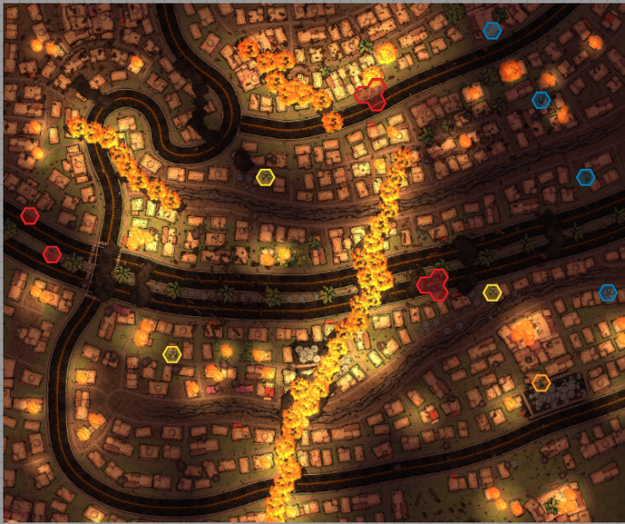
Map courtesy of @Starwall
Available in the Wallflower Community Resources folder.

OBJECTIVES

PRIMARY OBJECTIVE
The PCs must traverse the still burning ruins of Hivehome to reach their mechs in order to come to the defense of HiveHome.

CHALLENGES
The PCs will need to choose how to approach a number of secondary objectives that will pop up as they progress. Roll or choose 3-6 times to start with and place them on the map.If you’re using the map on the previous page the fires and rifts are depicted on the map, but rolling these could indicate fires growing out of control or new rifts opening.

Challenge | ROLL 1D6
1 | Civilians | Numerous groups of civilians need assistance. They could be trapped in a collapsed or burning building, hunted by Subalterns or panicking.
2 | Subaltern Squad | Roving bands of Subalterns are clearing buildings, searching for survivors. They are shooting Hercynian’s, Egregorian’s and the PCs on sight.
3 | Rifts | Several chasms have opened up across the city, many spewing fire and molten rock. Crossing these chasms without the right equipment will be risky.
4 | Falling Rocks | Huge boulders continue to fall from the damaged ceiling above. PCs must keep an eye out for house sized rocks from above.
5 | Fires | Fire from the chasms and other sources are spreading quickly. Smoke from these fires are hazardous to unprotected people and the fires threaten to close off routes to the PCs mechs.
6 | Egregorian Sniper | An old Egregorian has grabbed an antique rifle from their home and begun taking shots at a group of Subalterns clearing buildings down the road from them, drawing their fire. It is obvious from the machine tactics that the Subalterns will soon overwhelm the sniper.

CONSEQUENCES
Surviving such a devastating attack will require grit and heroism and leave a lasting mCiviark. Use Risky, Difficult and Heroic skill checks and challenges liberally and don’t be afraid to doll out Stress as consequences for failed rolls. If a character Breaks during this scene, they will need to be carried to their mech. Performing actions while carrying an incapacitated friend is Difficult, but working together and Pushing themselves can stack the odds in the PCs favor.
If PCs have the right pilot equipment for a task you may want to grant increased effect, downgrade a roll, reduce difficulty, add accuracy or maybe even bypass certain rolls altogether.

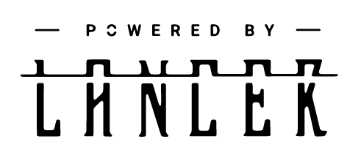

Tumbledown Narrative Encounter is not an official Lancer product; it is a third party work, and is not affiliated with Massif Press.

